Road Accident Data Analysis and Risk Predictor
Contents
Analysis 2
Problem Description 2
Stakeholder Identification 3
Primary Stakeholders 3
Secondary Stakeholders 3
Research and Investigations 3
Existing solutions 3
ETHICAL, CULTURAL, environmental, AND LEGAL CONSIDERATIONS 7
PRIMARY RESEARCH 8
Proposed solution 16
Success Criteria 16
Programming language implementation 16
Software Deployment Reasoning 17
Project Objectives 17
Design 19
Description 19
SYSTEM ARCHITECTURE OVERVIEW 20
User Interface (UI) Layer 21
Low AND MEDIUM FIDELITY Prototype 21
High Fidelity Prototype 24
IPSO CHARTS 26
IPSO chart on calculating risk based on user input. 26
IPSO CHART ON VISUALISATION RENDERING 27
DATA FLOW DIAGRAM 28
KEY Data TRANSFORMATION PIPELINE 29
CLASS DIAGRAM 29
UML CLASS DIAGRAM 29
Module Responsibilities 30
Data Structure Design 30
Pandas DataFrame Schema 30
ERROR HANDLING 30
Algorithms 31
Pseudocode for weighted risk calculation MODEL 31
PSEUDOCODE FOR ERROR HANDLING 32
DESIGN PROJECT OBJECTIVES (PO) AND SUCCESS CRITERIAS (SC) ACHIEVED/contributed to 33
Technical Implementation 34
DATA LOADING MODULE 34
RISK ENGINE MODULE 38
CHART CREATION MODULE 44
MAIN MODULE 47
REQUIREMENTS 59
READ ME 59
TECHNIQUES USED 60
TABLE A 60
TABLE B 61
TABLE C 61
INTERFACE SCREENSHOTS 62
TESTING 71
TESTS 71
EVALUATION 89
PROJECT OBJECTIVES 89
CONCLUSION 91
USER FEEDBACK SURVEY 91
QUESTIONS 92
ANSWERS 93
IMPROVMENTS 94
Bibliography 95

Analysis

Problem Description
Every year, thousands of road accidents happen around the UK, many of them are caused by poor weather, lightning, or human error. Government data does exist, but it is large making it hard for the average person to comb through and interpret. Currently there is no free simple tool that allows people to analyse patterns in road accidents, visualise these patterns in clear and understandable ways, and predict the likelihood of an accident occurring in specific conditions.
To solve this problem, I am aiming to create a python-based data analytical system that can: Load and process accident datasets, visualise accident trends and hotspots, and can predict the relative risks of accidents under certain conditions such as weather, road type, season, and time of day. This system would assist drivers in making safer driving decisions and provide road planners with easily understandable insights.

Stakeholder Identification

Primary Stakeholders
- Drivers: My primary users are going to be drivers of varying ages. My product would help them by showing them when and where accident risks are statistically higher so they can make better data driven decisions.
- Software Developer (Me): I am responsible for designing, implementing, testing, and evaluating the software. I have a responsibility to ensure it is ethical, accurate, and legally compliant.

Secondary Stakeholders
- Road Planners: They are responsible for planning new roads or modifications to current roads to optimise the flow of traffic. They could use this tool to identify high accident risk locations or recurring accident patterns, using them to design safer road infrastructure.
- I will be the primary user and developer because I am a driver, however, to remove any bias I might have as a developer and to give me more clarity into what other drivers want, I will collect feedback from other drivers throughout the development process.

Research and Investigations

Existing solutions
- The Official Governement Department for transport
- Crashmap.co.uk: This is an online platform that provides access to UK maps showing collision data sourced from the Department for Transport, which is based on police force records; their database is updated annually when a new record is published. It offers other features based on the user's needs and price tier. Their platform visualises accident data using an interactive map and categorises the collisions based on severity.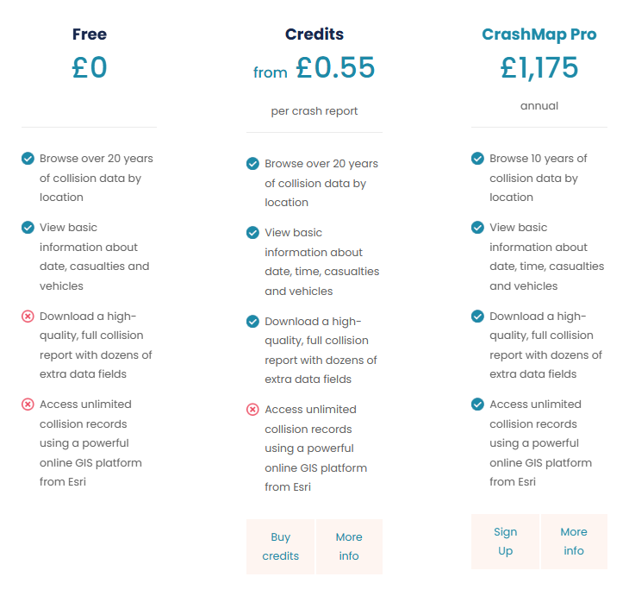
Figure 1 Screenshot of crash map pricing tiers
- The free tier allows users to browse over 20 years of location-based collision data and view basic information about the date, casualties, and vehicles involved in the crash. Alternatively, users can purchase credits costing £0.55 per crash report to access all the data from the free tier, plus download a high-quality, full collision report with dozens of extra data fields. The highest tier is called CrashMapPro and is an annual subscription costing £1,175, it gives user access to all the features offerd in the free and credit tier but they get unlimited access to collision records using an online GIS platform ( A GIS (Graphic Information System) platform is a technology that captures, stores, analyses, manages and displays various types of location based data) from Esri ( A web GIS mapping software).
To use the software, users must create an account using their full name and email address to log onto the platform. To test the platform, I created an account, logged into the platform, and since I don’t have any credits or the pro version, it defaults me to the free tier. I will not be buying credits or upgrading to the pro tier because my final intended product will be free. After logging in, I was taken to a map with different coloured tags on locations where accidents previously occurred.
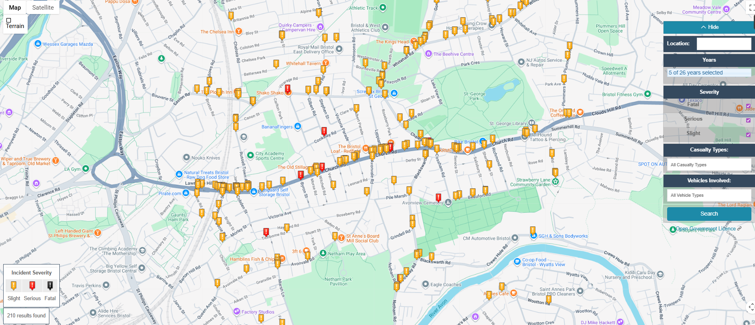
Figure 2 Screenshot of the homepage of crash map
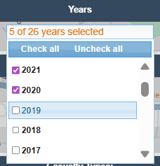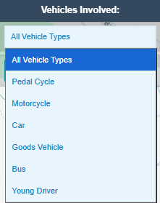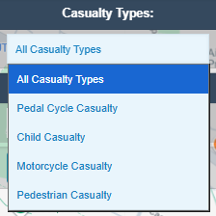
Figure 3 Expanded view of how to the vehicle type filter
Figure 4 Expanded view of the age filter
Figure 5 Expanded view of the casualty type filter
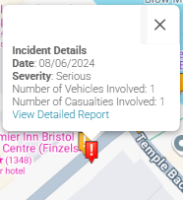
It gave me the option to change to a satellite view, search a location for previous accidents that occurred there, and filter results based on the year, severity (Fatal: Marked by a black tag, Serious: Marked by a red tag, and Slight: Marked by an orange tag), Vehicles involved, and casualty type.
Figure 6 Screenshot of an accident detail
Clicking on a tag prompts a pop-up with more details about that particular incident; The date, severity level, number of veichles involved, and the number of casualties involved.
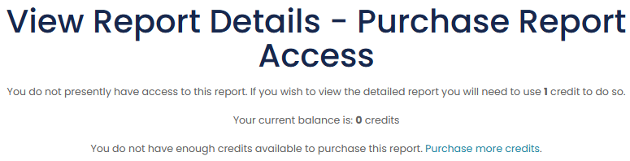
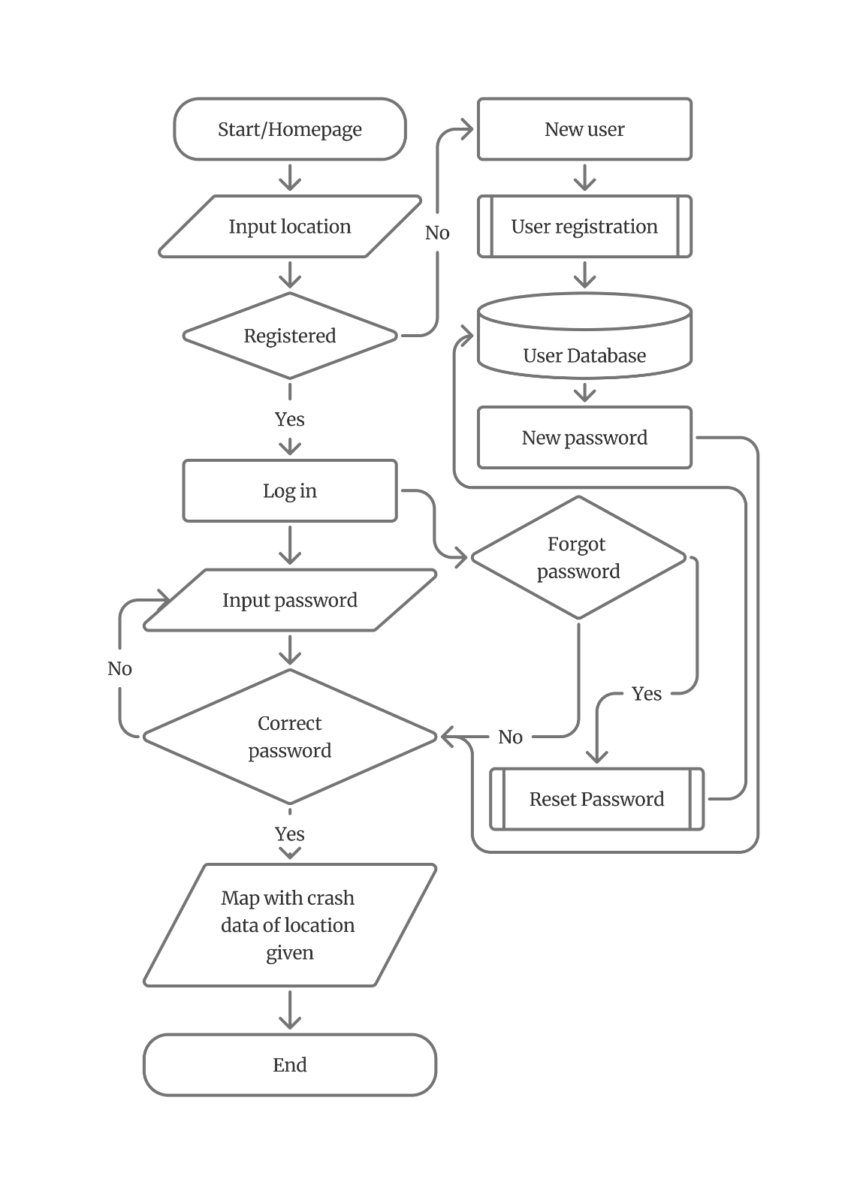
Figure 7 Screenshot of the view detailed report page
Clicking on “View Detailed Reports” takes me to another page telling me that I don’t have access to the detailed report unless I purchase credits.
Figure 8 Flowchart of the process to access crash maps data
To better visualise the process of accessing data on crashmaps, I created a flowcart focusing on the login/registration process required to access the acident data.
In summary, CrashMap is useful for viewing accident locations; however, the free version lacks important contextual data necessary to draw patterns and trends. Additionally, most of its key analytical features like trend analysis and condition-based filtering are locked behind a paywall, restricting non-paying users from gaining deeper insight into the accident data. My project aims to fix these issues by providing free access to clear data visualisation and meaningful analysis without requiring specialist GIS knowledge.

ETHICAL, CULTURAL, environmental, AND LEGAL CONSIDERATIONS

Ethical:
- Data accuracy & Misleading predictions: The system predicts risks based on historical data from the Department of Transport. So, it may output misleading predictions because of incomplete, outdated, or biased data. This can lead to drivers making unsafe decisions based of the system's predictions. I can prevent this by reminding users that predictions are not guarantees but advisory.
- Responsibility allocation: If an accident happens to a user following the system's advice, it calls into question who is responsible for it. The system must not be used to replace human decision-making but instead support it. I can prevent this by avoiding using adjectives such as “safe,” “dangerous,” or “Hazardous”.
- Data bias: Accident data may be biased due to social or infrastructural reasons, such as impoverished areas having worse roads and street lighting. This can lead to the system labelling such areas as “dangerous” without context. I can prevent this by avoiding ranking areas in a way that could stigmatise them.

Legal:
- Data protection regulation (GDPR): I must ensure that the data I use and collect complies with the GDPR and other data laws. I can solve this by storing users’ data locally. Additionally, the data set I am using for the system is from the government (Department of Transport), so it contains no personally identifiable information.
- Liability and Disclosures: The software must make clear to users that its predictions are not facts but just advisory. This is to prevent any legal liability in case of an accident.
- Use of third-party data/ Licensing issues: I am using government data, so I must follow its licensing terms. To adhere to them I must credit the Department for Transport as the source for the data and not monetise the data.

Cultural:
- Accessibility: My system needs to be non-complex so that older and less tech-savvy users can use it. To achieve this I can use iconography, legible typography, and simple non-technical language.
- Digital divide: Individuals without internet access or a device with a browser would not be able to access my system. However, this will not be a problem with my service because the UK as of 2024 has a phone ownership rate of 96% (Statista, 2022) with a majority of the remaining 4% being children and elders who mostly aren’t in my target market anyways (Drivers).
- Public trust in digital systems: There is a public distrust in automated digital systems due to a couple of factors, a major one being the lack of insight into how data is collected, stored and processed, this is especially prevalent in artificial intelligence systems due to their “Black Box” nature (Harper and Weber, 2022, pp.1-3). Decreased trust in my system would lead to a low adoption rate so to increase the rate of trust in my system I could give a brief and concise explanation of how my system analyses the data from the Department of transportation and uses it to produce an accident prediction. And if users want more information, I could add the option for users to get a more detailed explanation.

Environmental:
- Data processing typically consume a lot of energy, especially when cloud based. This contributes to pollution and climate change. To mitigate this, my software will handle all data processing and other computations locally on the user’s device.
- Safer driving behaviours could indirectly leads to less congestion which could lead to reduced emissions because cars are not idling in traffic.

PRIMARY RESEARCH
To confirm the validity of the problem and to gain insight into my users' needs and wants, I decided to conduct a questionnaire in the form of a survey. The survey would be conducted on Microsoft Forms and would be anonymous; anonymity could help boost honesty by removing the fear of judgment, thereby making the results more dependable. I aim to get a minimum of 50 responses from the survey from my primary stakeholders (Drivers). I would target them by posting the link on my college social media page and my personal social media pages. I am 17 years old, so many of my friends and acquaintances who follow me on social media are of a similar age, and some of them drive.

SURVEY QUESTIONS
- Do you drive? Yes/ No
- How long have you been driving? Less than 1 Year/ 1-3 Years/ 4-10 Years/ More than 10 years
- How often do you drive? A lot/ Moderately/ A little/ Not at all
- Have you been involved in a road traffic accident? Yes/ No
- If yes, what was the severity of the incident? Minor damage/ Injury/ Serious injury
- How safe do you feel driving? Very safe/ Safe/ Unsafe/ Very unsafe
- Does your perception of safety change depending on conditions such as time of day, weather, or road type? Yes/No
- Do you avoid driving in certain conditions because you believe they are dangerous? Yes/ No
- If yes, which conditions do you avoid?
- Would you find a software that provides data about accident statistics, patterns, and trends useful? Yes/No
- What type of visualisation would help you understand accident data the best? Maps/ Bar charts/ Line graphs/ Tables/ a combination of data types
- Would you trust a system that predicts accident risk based on historical data? Yes/ No
- How would you prefer the accident risk be shown? Percentage/ Risk levels (Low, Medium, High)/ Both
- What form would you like this software to take? Windows application/ website/ mobile application/ console application
- Would you pay for a system like this? Yes/ No
- Do you have any suggestions for specific data you would like the software to include? 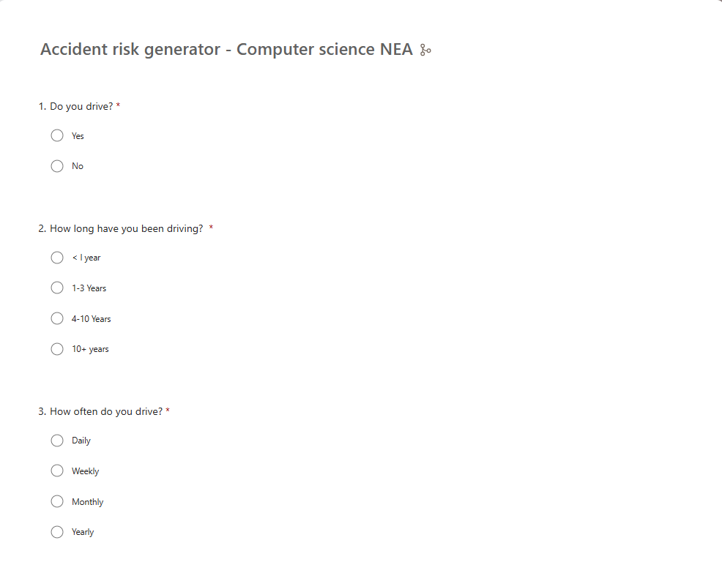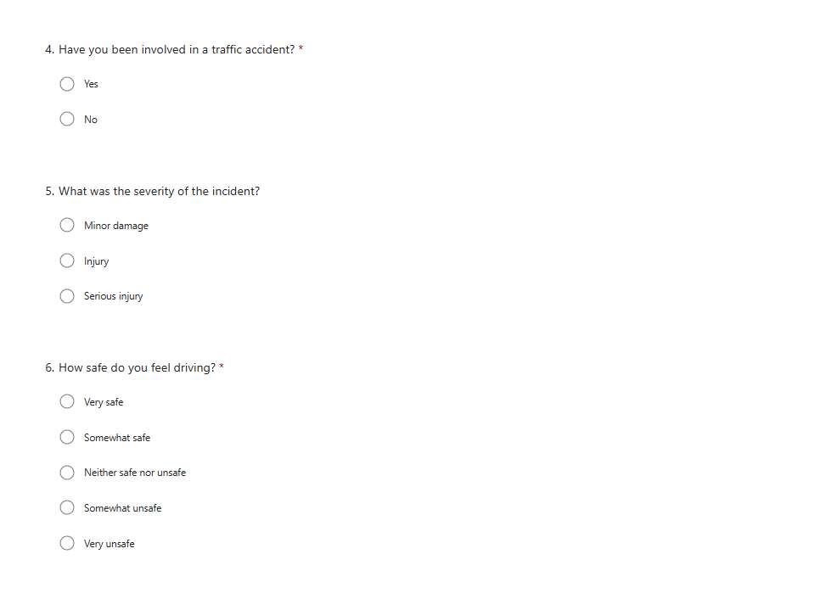
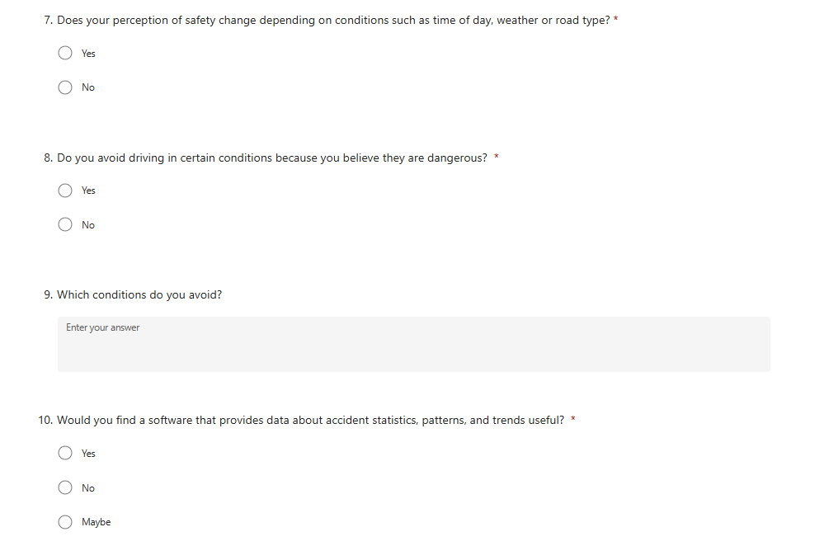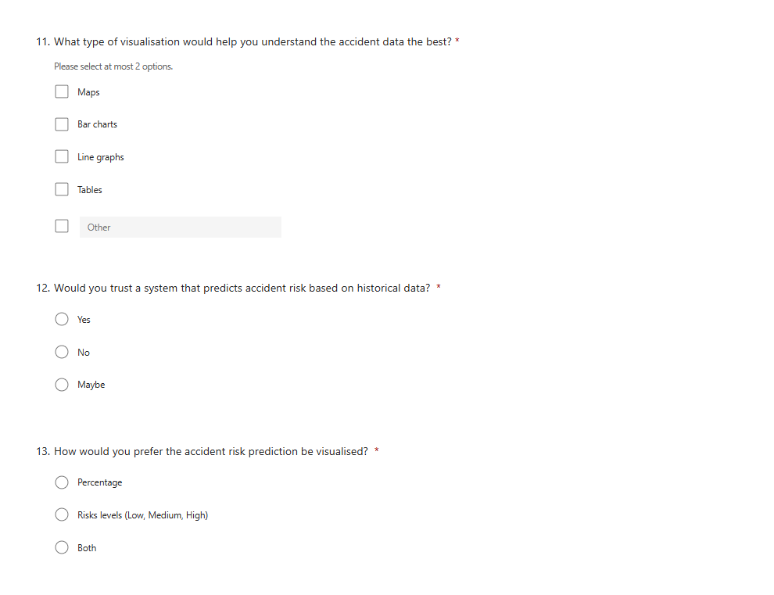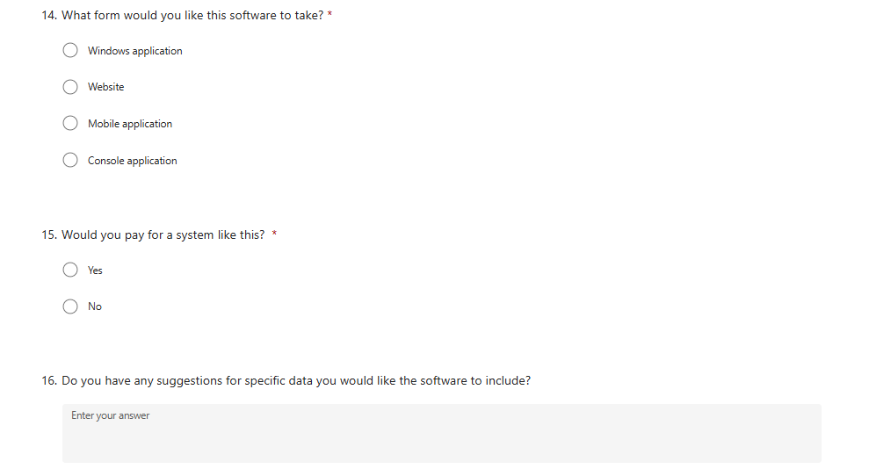
Above are screenshots of the survey in Microsoft Forms; some changes were made to the wording and answer choices for clarity's sake. To avoid responses from non-drivers, I used branching to end the survey for any participant who picked “No” for the first question.
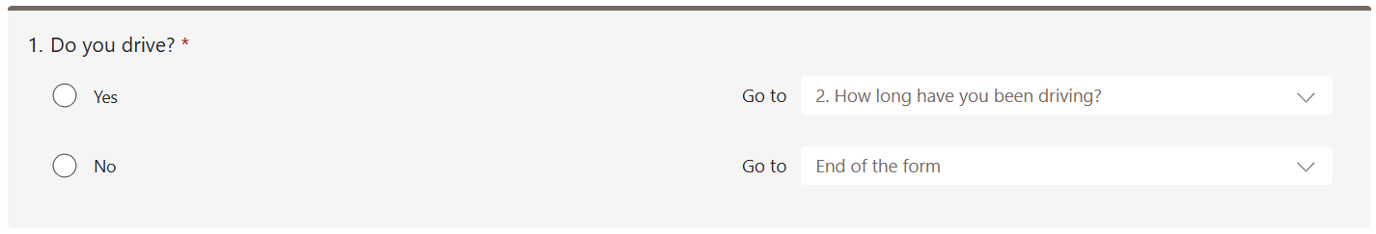
I also used branching in conditional questions where the second question depended on the answer of the first question, which are questions 4 and 5, and questions 8 and 9. This streamlines the experience for participants by skipping unnecessary questions, and it also provides more relevant and reliable data for me to make decisions based on. 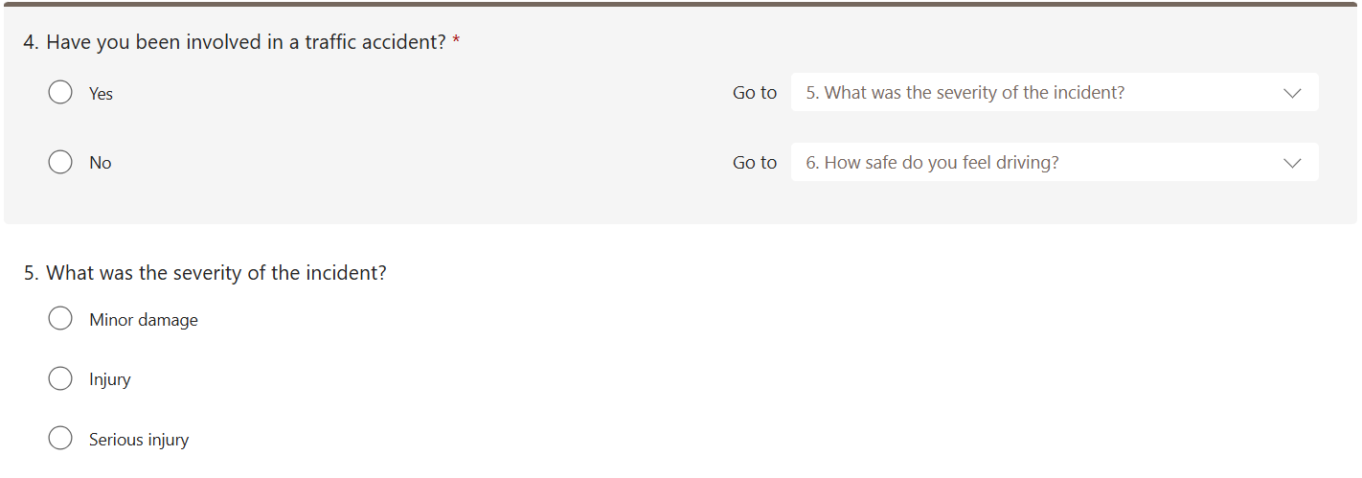
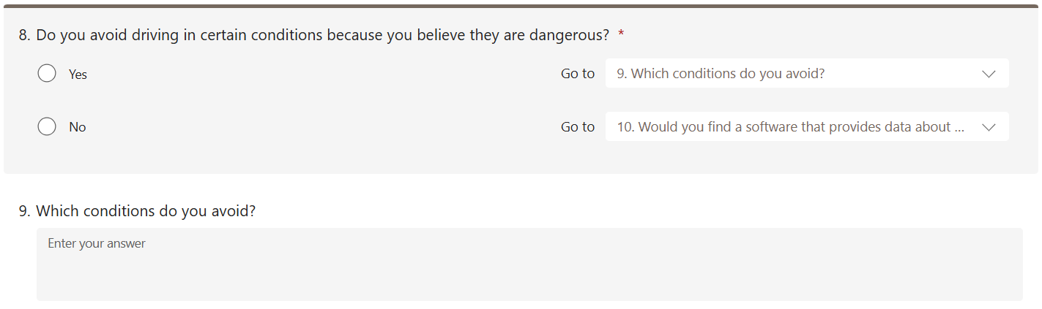

SURVEY RESPONSE ANALYSIS
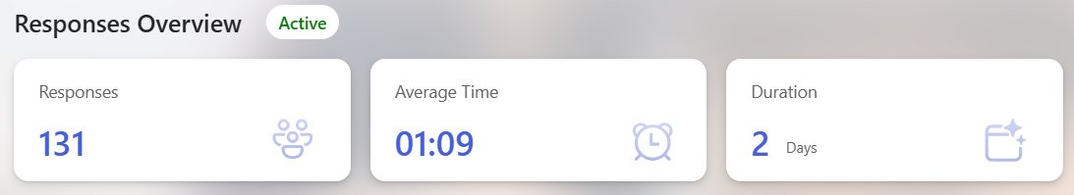
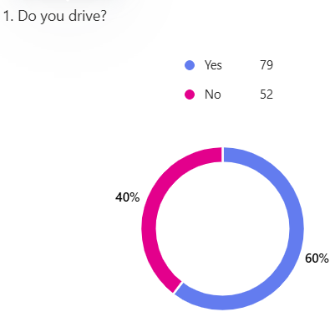
The survey received 131 responses within a day, 52 of which were from non-drivers leaving only 79 that are valid for my analysis.
Figure 9 Question 1 of the survey
- “Do you drive?”: 79 responses were “Yes,” and the other 52 responses were “No.” The respondents who answered “Yes” were moved on to the next question, while those who answered “No” had the survey end. So, although we had 131 responses, only 79 of them contain relevant data.

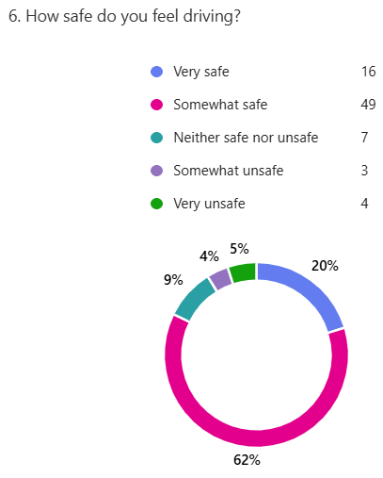
- “How safe do you feel driving?”: A majority of responders (49) chose “Somewhat safe,” which could imply they don’t always feel safe. We could get more insight into this by analyzing the next question in the survey, “Does your perception of safety change depending on conditions such as time of day, weather, or road type?” A majority of the responders (72) answered “Yes,” reinforcing my initial inference that most drivers don’t always feel safe on the road.
Figure 10 Question 6 of the survey
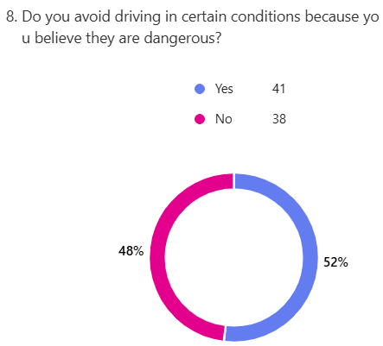
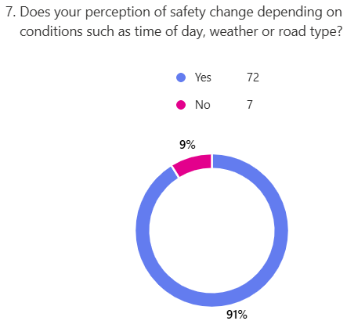
Figure 11 Question 8 of the survey
Figure 12 Question 7 of the survey
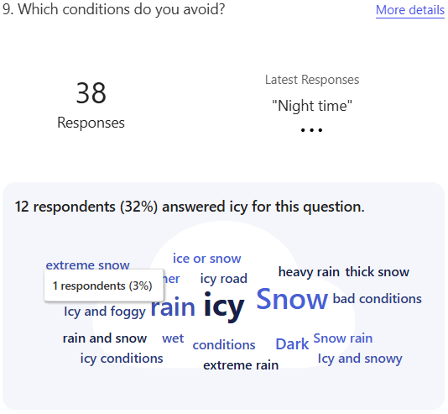
- “Do you avoid driving in certain conditions because you believe they are dangerous?”: 48% of respondents answered “No” as a minority, while the remaining 52% answered “Yes.” The responders who answered “Yes” were then asked: “Which conditions do you avoid?” Most of the respondents’ answers were related to either “Snow” or “Ice”. This reveals that most drivers have basic knowledge of accident data concerning factors that could increase the risk of driving. Snow and ice are factors that contribute to dangerous driving conditions, but there are other, more relevant factors that were mentioned less, such as time of day or visibility. For this reason, my project will also aim to educate drivers about lesser-known factors that contribute to dangerous driving conditions.
Figure 13 Question 9 of the survey

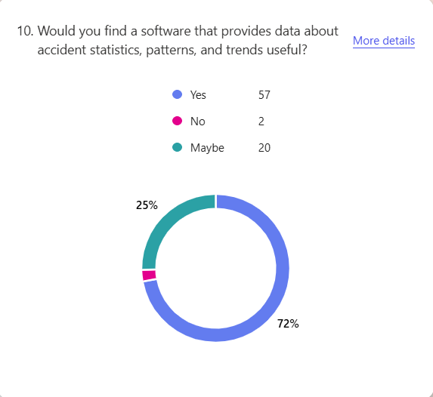
- “Would you find a software that provides data about accident statistics, patterns, and trends useful?”: A majority of the respondents (57) chose “Yes” while a minority (20) chose “Maybe” and 2 participants chose “No.” This reinforces my point in the stakeholder section that drivers would find a tool like the one I am trying to build useful.
Figure 14 Question 10 of the survey

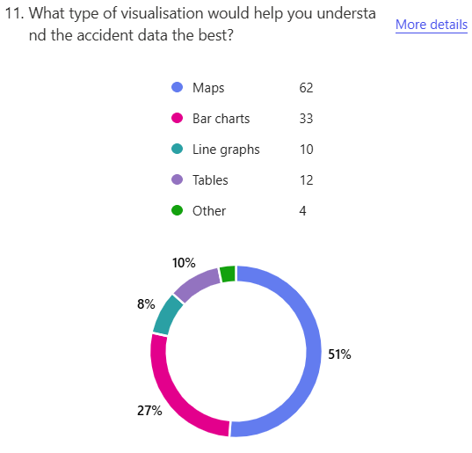
- “What type of visualisation would help you understand the accident data the best?”: Most of the responders (62) chose “Maps,” and the second most popular, with 33 respondents, was the “Bar charts.” Visualisation using maps would require learning several complex new programming languages, which would not fit into the time frame of the NEA project, so I decided to go with visualisation using bar charts and line graphs because it was the second most popular response. A respondent suggested using animations; I can experiment with adding animations in the technical solution part of my project to make it look more dynamic, therefore increasing viewers' retention.
Figure 15 Question 11 of the survey
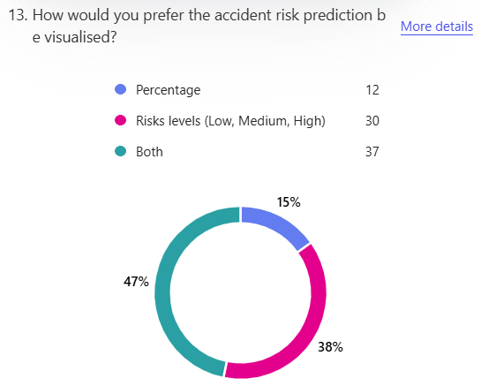
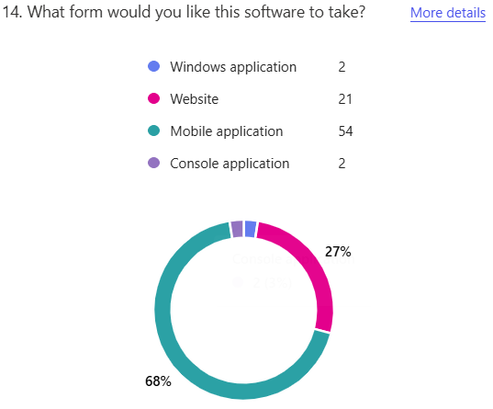
- “How would you prefer the accident risk prediction be visualised?”: Most users chose “Both,” so I would implement an option for users to choose how they want their data visualised or show them both at the same time. I could implement a system where the base rate of accidents is established as a percentage, and with the addition of any factor that increases the likelihood of an accident, I could increase the percentage of risk. Then I could set percentage thresholds to split the risk level into Low, Medium, and High.
Figure 17 Question 13 of the survey
Figure 16 Question 14 of the survey
- ““What form would you like this software to take?” : Most respondents (54) preferred the system to be in the form of a mobile application. However, this would require learning several complex platform specific coding languages for the different mobile operating systems, iOS and Android; this wouldn’t be possible to achieve within the timeframe of my NEA. The second most popular option was a website (21 respondents), I have considered running python in the browser using PyScript: However, my research into PyScript revealed it has slower performance for data intensive task (like mine), limited library compatibility, and limited browser compatibility. Therefore, I decided to deploy my software as a local python application, because it doesn’t have the drawbacks of the other deployment methods and has some pros, such as being able to work with large data sets locally.
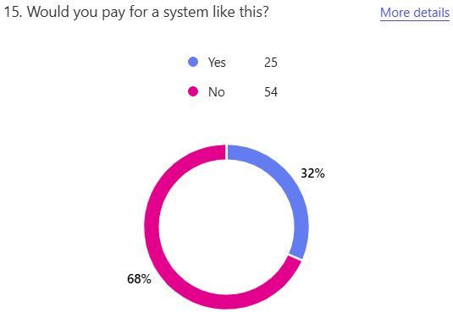
Figure 18 Question 15 of the survey
- “Would you pay for a system like this?”: Most respondents choose “No,” reinforcing my decision to make it completely free to users, unlike CrashMap and other alternatives.

- “Do you have any suggestions for specific data you would like the software to include?”: A majoity of reponses I got from this question were already features or data fields I already planned to add to my project with the exception of the two below:
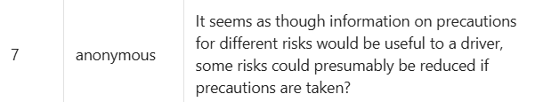
This response suggests that I provide drivers with information on precautions for different types of risks. This is a feature I will implement because, as the respondent noted, some risks are greatly reduced when appropriate precautions are taken. My program could implement this by identifying the key risk factors in a drive and then providing users with a description of precautions they can take to reduce the risk of an accident.
This response recommends not scaremongering users. Scaremongering could lead to drivers being anxious on a drive and increase the risk of accidents. To prevent that from happening, I could reassure my users that the predictions are based on previous data, therefore are not accurate. I will also remind them to focus on driving and nothing else.

Proposed solution

Success Criteria
To keep my project focused I will make a list of success criteria’s that my software must achieve. The criteria are based off the feedback and knowledge gained in the stakeholder identification, primary research, secondary research, and ethical, legal, cultural, and environmental consideration.
- SC1: Free access: The software must be completely free for users to access and use.
- SC2: Data-Driven Risk Prediction: The software must output an accident risk estimate using a minimum of four independent variables taken from the Department for Transport datasets.
- SC3: Clear Visualisation: The software must present the accident data using bar chart or other types of charts that clearly show trend, to allow users to interpret patterns without requiring raw data tables.
- SC4: Easy to use: The software must be easy to use for a first timer; they should be able to generate an accident risk prediction in less than six interactions without any guided instructions.
- SC5: Educational: The software must explain why a risk level was generated by breaking down the contributing factors and how much they influence the risk level.
- SC6: Logic Transparency: The software must allow users to view a clear explanation of how risk predictions are estimated, to avoid “black box” like behaviour.
- SC7: The software must only use anonymised government data, clearly state that risk predictions are only advisory estimates and not guarantees and, comply with the GDPR.
- SC8: The software must process all data locally on the user’s device without requiring an internet connection or external servers to minimise environmental impact, ensure data privacy, and remove reliance on external servers.

Programming language implementation
My project would need to process, store, analyse, and present data; to achieve that I will be using python in conjunction with its various libraries.
Python Library | Use and Reasoning
Pandas | Data handling: Importing and cleaning road accident datasets and handling missing, irrelevant, or inconsistent values.  Data Storage: It will be used to store accident data.  Data Preprocessing: It will be used to load data, drop irrelevant columns, and handle nulls.
NumPy | Used for statistical calculations on filtered subsets of the data such as averages, means, frequency, and variance. Additionally, it would be used to identify high-risk regions or conditions using array operations and descriptive statistics.
Matplotlib | This will be used for the backend rendering engine for seaborn and embedding plots into Tkinter.
Seaborn | This will be used as the primary library for data visualisation to create aesthetically pleasing bar charts and line graphs, it is built on Matplotlib which enables easy implantation into my Tkinter UI.
Tkinter | This will be used to create the software desktop user interface. I chose tkinter over other alternatives because of it is inbuilt into python, so it does not require any external dependencies. Additionally, it is easy to implement while still being capable of complex UIs which is perfect for my NEA time constraints.

Software Deployment Reasoning
I will be comparing the pros and cons of the other deployment strategies (PyScript web application and Flask web application) I was considering, justifying my decision to choose a local python desktop application.
Deployment strategy | Pros | Cons | Final Decisions
PyScript web app | - Can be accessed on any device with a browser.  - It requires no additional install to run. | - It runs slower than native local python, especially on data heavy tasks (like mine)  - It has limited library support.  - It is complex to debug. | Rejected
Flask web app | - It is easy to create a web UI using HTML and CSS.  - It can have a full python backend. | - It requires users to run a local server which would not be ideal for non-tech savvy users or users who wants a software that just works with no/little setup. | Rejected
Python local app | - It has a robust library collection.  - It is easy to test  - It can be distributed easily. | - It requires the device that it is running on to have a python installation; my software solves this by including instructions on how to run it, in the distribution. | Accepted
The distributions would provide the source code in python, with an additional text file with instructions and requirements to run it.

Project Objectives
- Data handling objectives:
  - The software must import and process official data from the UK Department for Transport’s accident datasets.
  - The software must clean up the dataset by handling missing, inconsistent, or irrelevant data fields.
  - The software must allow users to filter accident data using a minimum of four independent variables, such as weather, road type, season, and time of day.
  - The software must store and modify data efficiently using data structures such as arrays.
- Risk prediction objectives:
  - The software must output an accident risk estimation based on the user’s selected conditions.
  - The risk prediction must be based on statistical, or machine learning estimates extrapolated from historical data.
  - The software must display risk estimates as both:
  - A percentage value
  - A categorical risk level (low/medium/high risk)
  - The software must clearly explain to users how a risk estimation was calculated, showing the contributing factors.
  - The software must clearly state that the risk predictions are advisory estimates to be used to aid decision-making and not guarantees.
- Data visualisation objectives:
  - The software must output clear visualisations of accident trends.
  - The software must show trends over time using:
  - Bar charts
  - Line graphs
  - The software’s output visualisations must update based on user-selected filters.
  - The software must allow users to easily interpret accident patterns without requiring the raw datasets.
- User Interface (UI) objectives:
  - The software must run locally as a desktop application on windows, macOS and Linux using Python and Tkinter.
  - The software must allow users to generate a prediction in less than six interactions.
  - The user interface must be accessible to less tech-savvy users by implementing industry-standard axioms:
  - Legible typography
  - Consistent colour schemes
  - Simple non-technical jargon
  - Icons
  - Structured layouts
- Educational objectives:
  - The software must display precautionary advice to users based on identified risk factors.
  - The software must avoid the use of scaremongering language.
  - The software must include a section detailing the logic behind the prediction estimates to avoid “black box” like behaviour.
- Legal and ethical objectives:
  - The software must only use anonymised government datasets.
  - The software must credit the UK’s Department of Transport as the data source.
  - The software must comply with UK General Data Protection Regulation (UK GDPR) requirements.
  - The software must process data locally whenever possible to minimise its environmental impact.
- Accessibility and practical constraints objectives:
  - The software must be free to use.
  - The software must not require users to create an account.
  - The software must be sharable as a python file and include clear step-by-step instructions to run it.
  - The software must include an instruction file (on how to setup the software for first time users) as part of the accompanying documentation.
  - The software must be able to be coded within the time constraints of the NEA project.

Design

Description
My project design aims to create a python application that analyses traffic accidents to provide risk predictions, with the goal of helping to reduce the thousands of road accidents happening across the UK. I aim to design a software that is visually aesthetic while being functional and accessible to users of all technological skill levels. The software user interface (UI) will be clean and minimalist to focus on usability and clarity; additionally, data visualisation will be prioritised over raw data tables, to make it easier for users to interpret and process the data. To improve accessibility, I will implement standard user experience principles such as icons, legible fonts, a consistent colour palette, and step-by-step input guidance.
Users will have the option to select a filter based on their current situation (such as choosing the filter rain on the situation weather) to calculate a relative risk estimate percentage and a risk level (high, medium low). Additionally, it provided users with precautionary advise to minimise the danger of a risk; such as, if snow is one of a user’s filter in weather, then they would get a precautionary advice telling them to drive slower and use the highest gears possible to reduce wheel spin.
Furthermore, the user can select a situation (weather, road type etc.) and then a bar graph would break down the accident death by filter ( for example 100k death from snow, in situation weather) this would educate users on what conditions can affect their risk of accident and will help them make better driving decisions even when not using my software.
All data visualisations (graphs, bar chats, line graphs) will be generated using Seaborn (Matplotlib backend) and will be embedded directly into the Tkinter UI to ensure that the data is rendered quickly. The backend processing (data handling, risk calculation, visualisation, and user interface) is going to be treated as loosely coupled modules; This decomposition makes it less daunting for me to approach the technical solution and has the benefit of making the different modules easier to debug and test.

SYSTEM ARCHITECTURE OVERVIEW
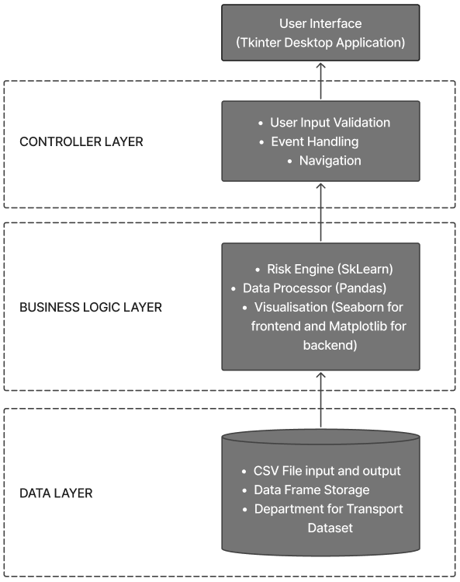
Figure 19 System Architecture Overview
This is a system architecture overview of my software. Using decomposition, I broke down my application into 4 layers: User Interface, Controller Layer, Business Logic Layer and Data layer. Each layer has one responsibility making the system easier to debus and text by allowing me to independently test, debug and modify for example in the data layer I can swap data source from CSV to SQL without affecting any other layer.

User Interface (UI) Layer
My user interface is going to be just one page; this is to fulfil one of my key objectives; A user being able to generate a risk estimate in less than six interactions.

Low AND MEDIUM FIDELITY Prototype
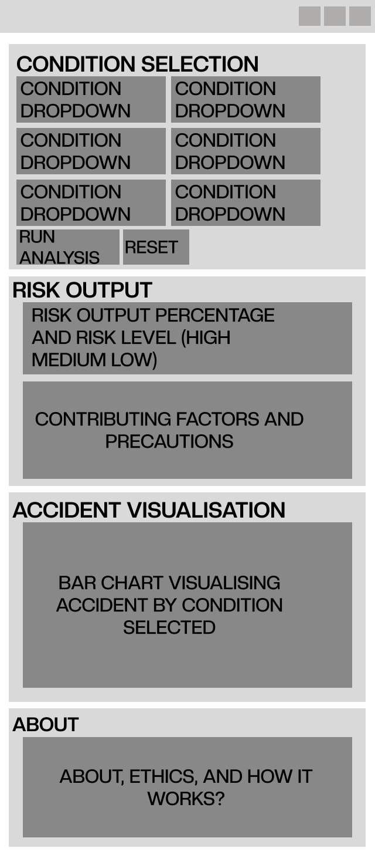
To begin designing my UI, I will start by creating a low fidelity prototype to roughly map out the layout of the different section, next I will create a medium fidelity prototype to map out the structure of where buttons and other visual elements are going to go and the purpose they serve. The prototypes will be created in Figma because it is a software with which I am familiar.
Figure 20 Medium-Fidelity Prototype
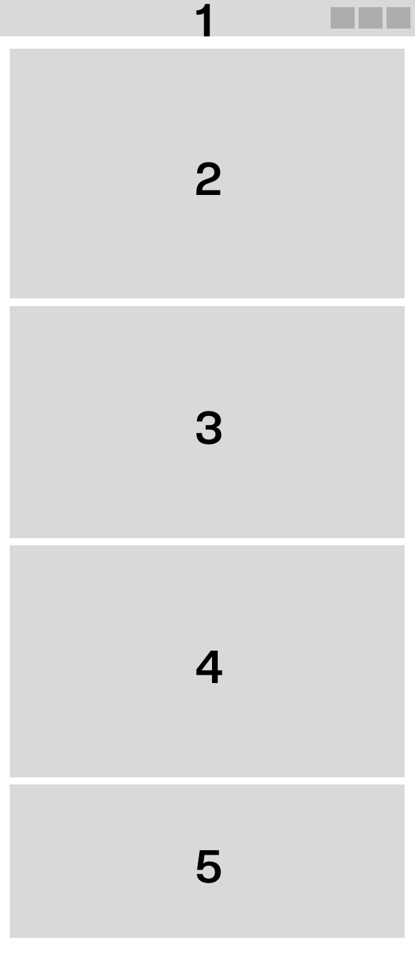
Figure 21 Low-Fidelity UI Prototype
UI Section | Medium-Fidelity | Purpose
1 |  | This is the top bar which will contain the software name and the first disclaimer about the advisory nature of the software.
S2 | 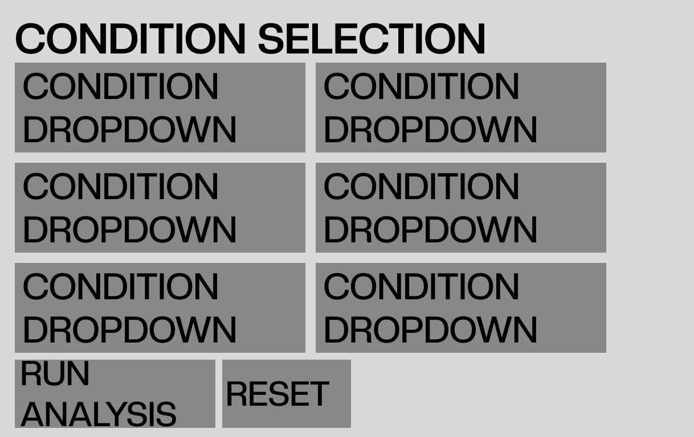 | This section, users choose from various conditions the one that suits them the best then run a risk analysis. The interface provides three types of buttons: The “Condition Dropdown” is a drop-down menu that allows users to select what conditions they are in (Weather would have the dropdown option of snow, rain etc). The “Run Analysis” button would be to trigger a risk analysis to be run only if there is a minimum of four conditions selected. The “Reset” button resets the risk analysis engine and clears the user input in the condition dropdown.
3 | 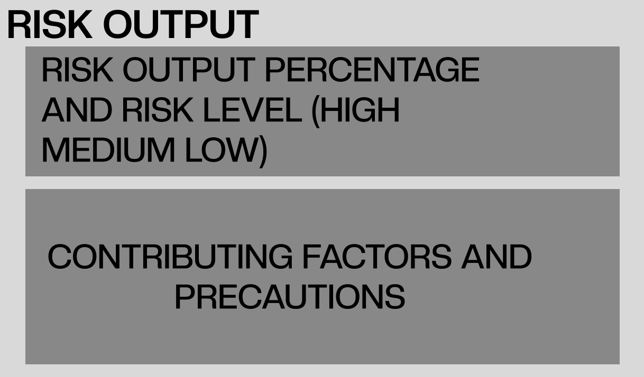 | This section outputs the risk as a percentage and as a level (High, Medium, or Low). Additionally, it displays the factors that contribute the most to the risk estimation and then displays precautions that can be taken to mitigate those risk (for example if rain was a high contributor to a risk analysis it would display a precaution telling the user to slow down on roads and to break gently).  The risk estimation will be displayed as a bar using intuitive colours (Red for high risk, orange for medium risk and green for low risk)
4 | 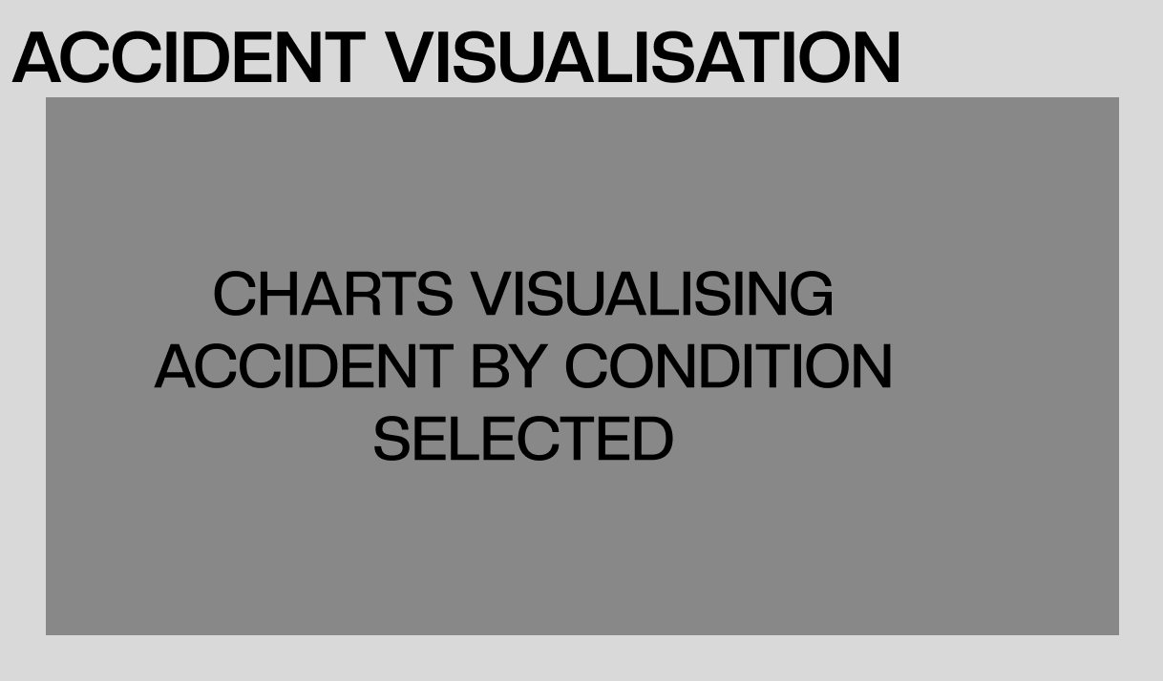 | This section visualises accident volume based on what filter the user selects, additionally users have the option to toggle between a bar chart and a line graph to visualise the data
5 | 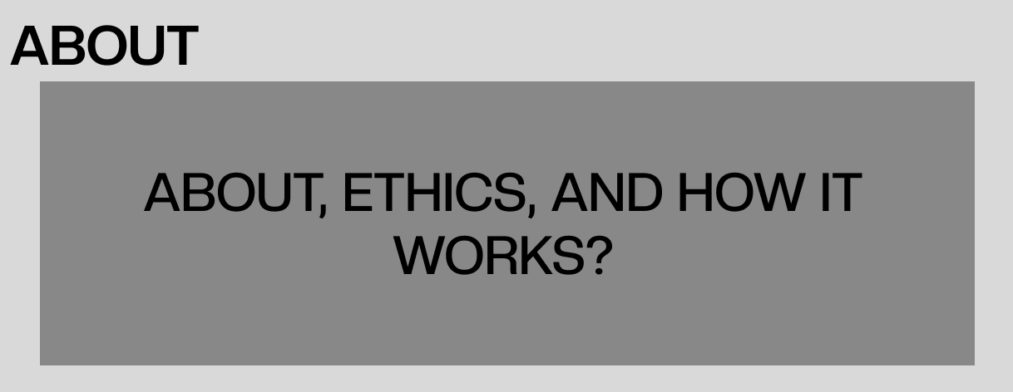 | This section is to inform the user about how a risk estimate is generated, credit the Department of Transport for the data use and inform the users of how their data is managed.

High Fidelity Prototype
Based on the medium fidelity prototype I will create a high-fidelity prototype to finalise the UI design aspect of the project. It will include the finalised colour scheme, layout, typography, and structure.
Colour Scheme: For the colour scheme I decided to use a dark blue colour for the backgrounds and white for the text, so they contrast each other making the text appear more legible. For sections I wated users to pay the most attention to like buttons or disclaimers I changed their colours to either bright green or bright red because their vibrancy stands out on the dark background making them seem more important.
Font: For the font I went with a serif font called “Creato display”; serif fonts are more legible than non-serif fonts due to their simplicity especially when being read from afar. For text you can interact with like buttons, drop downs, or toggles I used capital letters to show their importance but for non-interactable text for disclaimers, precautions ethics etc, I used normal capitalised italic letters to denotate that they are static.
Design element | Objective fulfilled | Reasoning
Single-page layout | SC4: Less than 6 interactions to get a risk prediction estimate | Filters, risk output, risk visualisation and about and ethics are visible on boot
Dropdown filters | SC4: Ease to use | No need for typing
Progress bar risk indicator | SC3: Clear visualisation | Globally recognised colour coding (green, orange, and red)
Contributing factor breakdown list | SC5: Educational | Shows the factors that contribute to the risk estimation
Precautionary advice | SC5 and Survey Q16: Educational | Shows advise based on the factors that contributed to the risk estimation
Chart toggle buttons | Survey Q11: Visualisation preference | Allows users to choose between a bar chart or a line graph
Risk calculation explanation | SC6: Logic transparency | Shows users how the risk estimation is calculated to avoid “black box” behaviour.
Legal and advisory disclaimers | Legal: Liability (Analysis) | Legal disclaimers and data privacy information to conform to the GDPR
Legible typography | Cultural: Accessibility (Analysis) | Legible serif font on high contrast backgrounds
Icon + text labels | Cultural: Accessibility | Icons are universally recognised regardless of language.
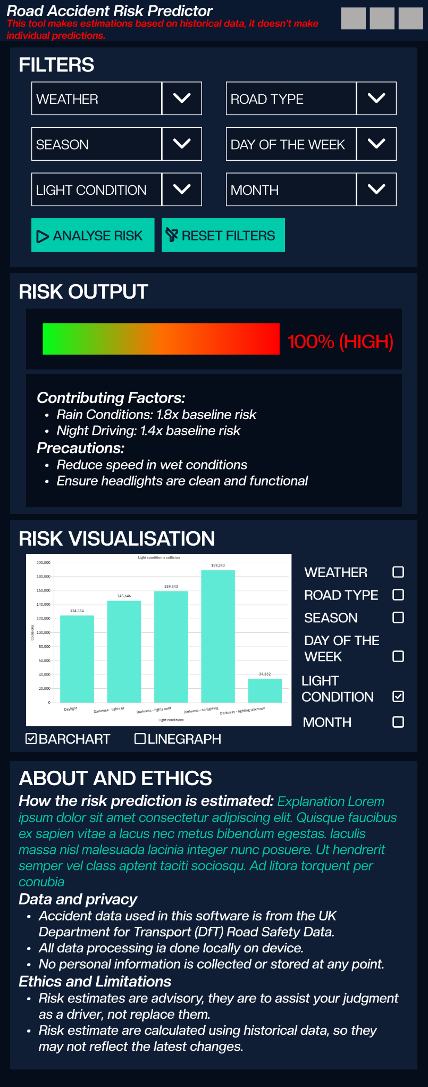
Figure 22 High-Fidelity UI Prototype
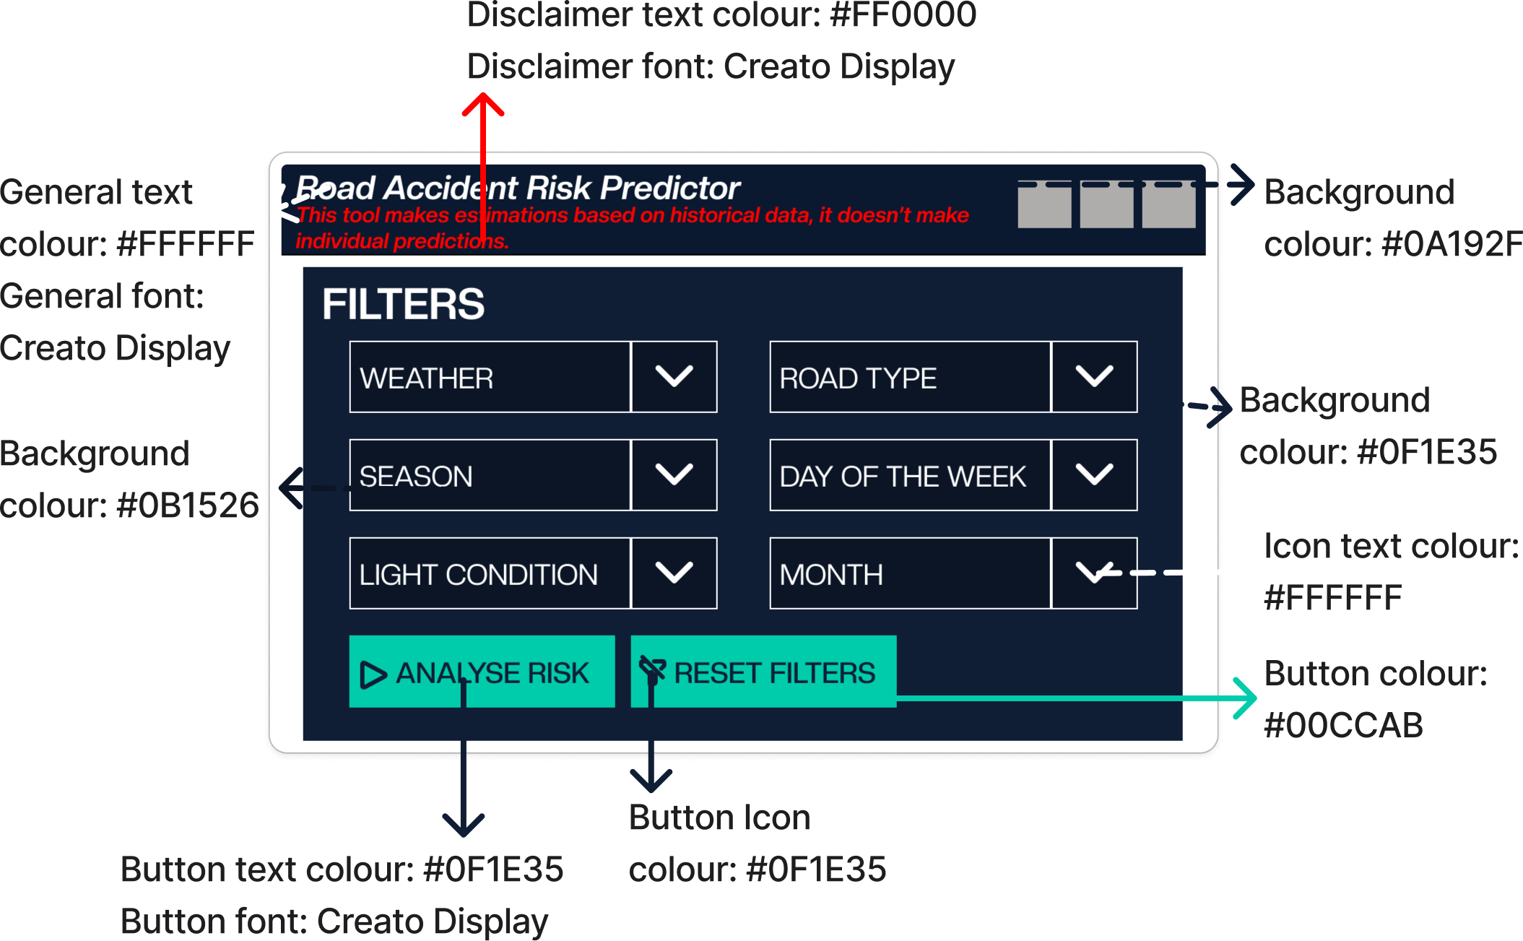
Figure 23 Colour and font UI breakdown.

IPSO CHARTS

IPSO chart on calculating risk based on user input.
Input | Process | Storage | Output
- User filter selection ( >= 4)  - Cleaned accident data frame.  - Predetermined factor weights | - Validation of filters (>=4)  - Fetch filtered subset from data frame.  - Calculate baseline accident rate.  - Multiply weighted adjustments per factor  - Convert to a percentage scale of 1-100.  - Categorise as a risk level (High, Medium, Low)  - Generate explanation.  - Lookup precautionary advice specific to the factors. | - Temporary storage of the Data frame subset (the one selected by the user)  - Risk results  - List of contributing factors. | - Risk percentage (float)  - Risk level (string)  - Explanation of risk calculation (string)  - List of precautions (List)  - Updated UI elements

IPSO CHART ON VISUALISATION RENDERING
Input | Process | Storage | Output
- Aggregated accident data (grouped by user filter selection)  - Chart type selection | - Select seaborn plotting function.  - Configure axes labels and title.  - Apply colour palette and font to fit my theme.  - Generate Matplotlib Figure  - Convert to Tkinter  - Embed in Canvas Widget  - Binds resize event handler | - matplotlib.Figure object  - tk.Photoimage reference  - Chat configuration dict | - Rendered accident data chart in UI

DATA FLOW DIAGRAM
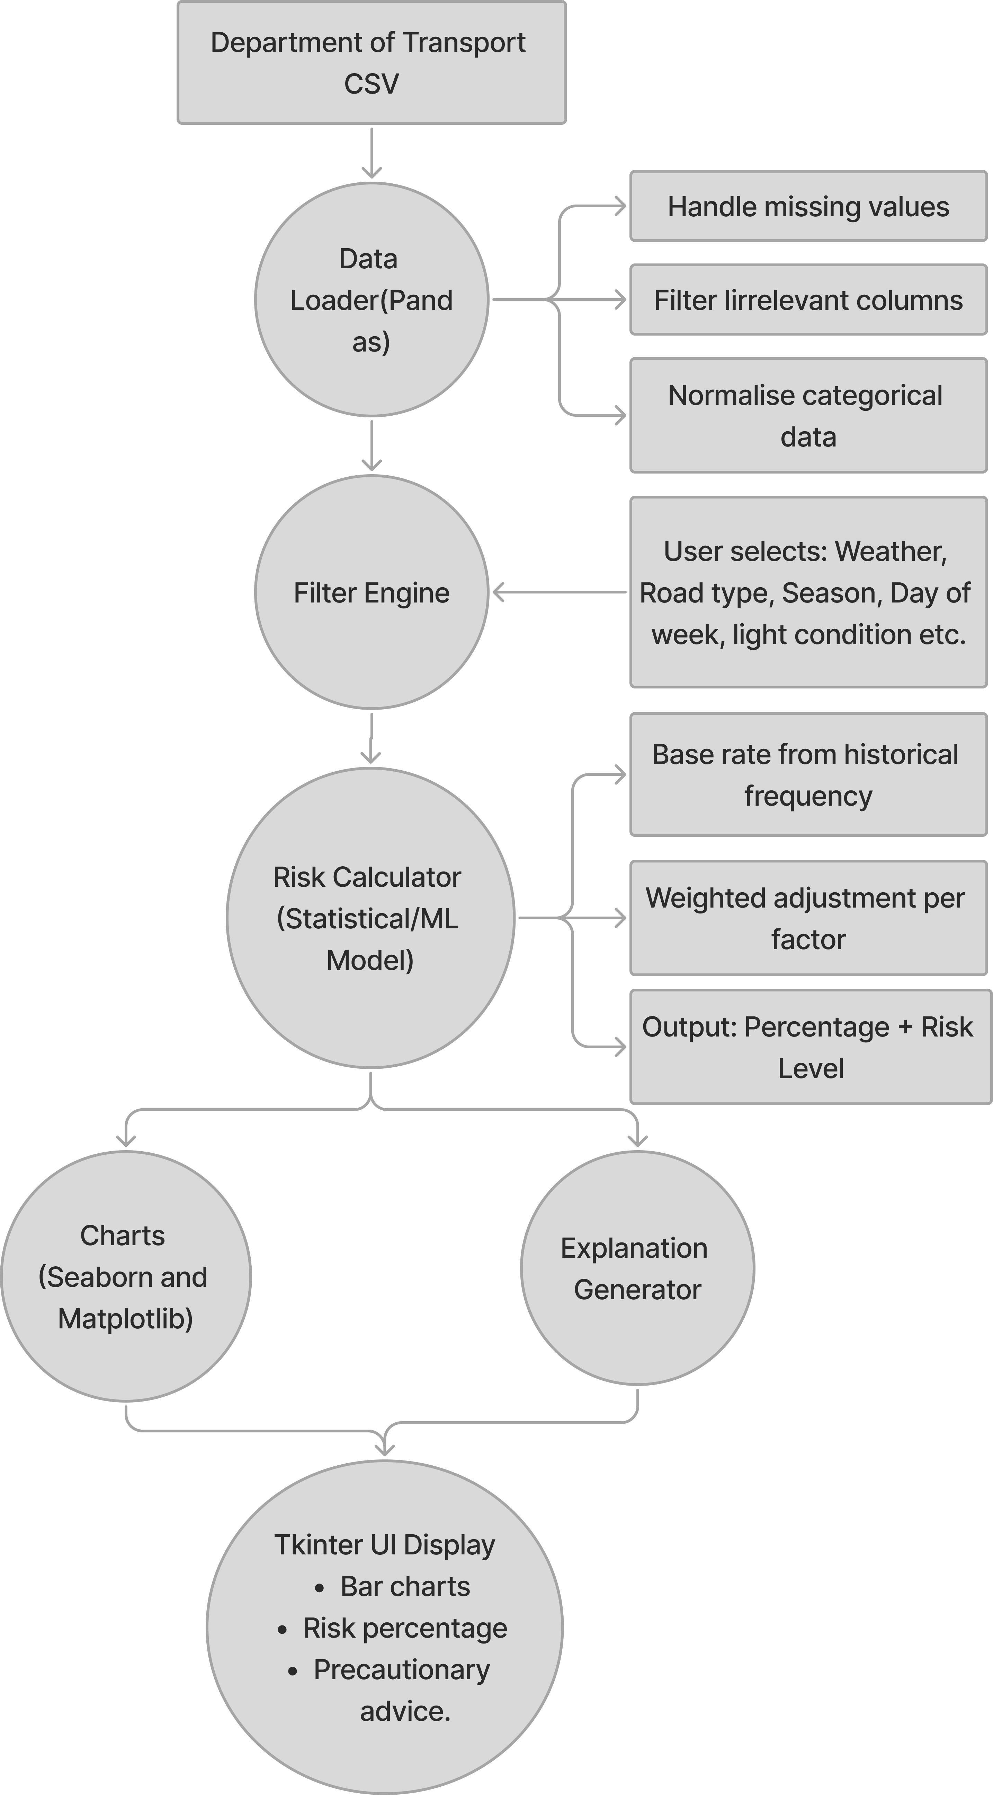
Figure 24 Logical Data Flow Diagram
This is a logical Data Flow Diagram (DFD), it provides a high-level view of the data flows that are required to generate an accident prediction and visualise accident data. The clear data input and output points makes it easy to debug. Additionally, by placing the filter engine before the risk calculator it ensures that the output risk generated is always based on the users’ selections, fulfilling success criteria two.

KEY Data TRANSFORMATION PIPELINE
Stage | Input | Process | Output | Purpose
Load data | Raw CSV from the Department of Transport (100k+ rows) | pd.read_csv(), dropna(), astype() | Clean dataframe | Prepare the data to be analysed.
Filter data | Clean dataframe + User condition selection | Boolean indexing on 4+ columns | Filtered data subset | Enables condition-based analysis
Aggregate data | Filtered dataframe | groupby(), value_counts(), mean() | Statistical summaries | Calculates a risk baseline
Predict risk | Aggregated statistics + weights | Weighted formular/sklearn model | Risk percentage + category | Generates precautionary advice
Visualise accident data | Aggregated data | Seaborn barnplot(), lineplot() | Mathplotlib Figure | Predict trend.
This is a data transformation table that shows each stage of the data processing pipeline: Loading, Filtering, Aggregating, prediction, and visualisation. It shows the input, process, resulting output and purpose of the stage, helping to serve as a reference during the technical implementation stage of my project. Additionally, breaking the data processing pipeline into specific stages makes the software easier to test.

CLASS DIAGRAM

UML CLASS DIAGRAM
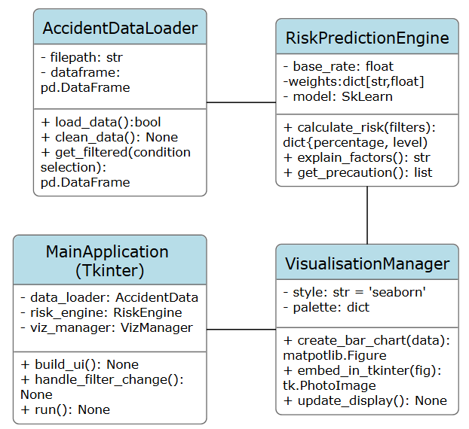
Figure 25 UML Class Diagram

Module Responsibilities
Module | Main Class/Function | Purpose
data_loader.py | load_dataset(), get_dd_options() | To enable swapping data sources without affecting other parts of the software
risk_engine.py | RiskResult, calc_risk() | To allow using statistical model to calculate estimated risk.
chart_engine.py | build_chart(), axis_lab() | To connect seaborn(frontend) and Matplotlib(backend) with Tkinter.
main.py | RoadRiskApp, _head(), _filters(), _risk_output(), _visualisation(), _about() | To build a UI to hide the complexities of the backend logic.

Data Structure Design

Pandas DataFrame Schema
Column | Data Type | Purpose | Source
date | datetime | Risk factor filter for season and day of the week | Department for Transport
weather_conditions | categorical | Risk factor filter | Department for Transport
road_type | categorical | Risk factor filter | Department for Transport
light_conditions | categorical | Risk factor filter | Department for Transport
casualties | int | Severity weighting | Department for Transport

ERROR HANDLING
Scenario | Potential problem | Solution/prevention | Objective fulfilled
Empty filter result | Risk calculation fails to output. | Print an “insufficient filter” message or disable the “Analyse risk” button if less than 4 filters have been inputted. | SC4, SC7
Corrupted CSV file | Application crash on boot | Print a message to the users explaining the reason for the crash and then terminate the program | SC7, SC8
Missing data column | Risk calculation cannot occur | Checks if all data columns needed are present and if not, it outputs an error message specifying what column is missing. | SC4, SC5

Algorithms

Pseudocode for weighted risk calculation MODEL
FUNCTION calculate_risk(user_filters: dict):
factors = [weather, road_type, time_of_day, day_of_the_week]
baseline = historical_data[accident_count]mean
risk_score = baseline
contributing_factors = []

FOR each IN factors:
subset = historical_data[historical_data[factor] == user_filters[factor]]
factor_rate = subset[accident_count]mean
multiplier = factor_rate / baseline
risk_score = risk_score*(1+(multiplier-1)* WEIGHTS[factor])
contributing_factors.append([factor, value, impact, weight])

risk_percentage = convert_to_percentage(risk_score, baseline)

IF risk_percentage < 33:
risk_level = "low"
ELSE IF risk_percentage < 66:
risk_level = "Medium"
ELSE:
risk_level = "High"

explanations = generate_explanations(contributing_factors, risk_score)
precautions = lookup_precautions(contributing_factors)

OUTPUT ("percentage: " risk_percentage, "level: " risk_level, "explanation: " explanations, "precautions: " precautions)

END FUNCTION
This is my pseudocode for my weighted risk calculation model
This model uses 4 independent variables (weather, road_type, time_of_day, day_of_the_week) to calculate the accident risk, the variable are independent because they are input conditions that affect the risk level without being affected by it. Each variable represents a real factor; weather represents external environmental conditions that could influence other factors like tyre grip, visibility etc. For each selected variable, the model filters through the data set to calculate a condition-specific accident rate, this is then compared to the baseline accident rate to produce a risk multiplier for that specific condition. The multipliers are then applied using a weighted adjustment; this ensures that each variable contribution is proportional to the final risk score. I used 4 independent variables to increase the complexity and realism of the model, enabling it to account for a wide range of contributing factors.
Early on in my design stage I considered using a machine learning risk calculation model, but I decided against that because, a weighted model would more suit my success criteria: SC6 (logic transparency to avoid “black box” behaviour. In the context of my solution, the model contributes to achieving SC2, PO1.3, PO2.1 by outputting a risk estimate based on a minimum of four independent variables taken from the Department of Transportation. Additionally, it contributes to SC7 and PO2.4 by outputting an explanation of how the risk prediction was generated. Furthermore, it satisfies PO2.2, PO2.3 by making a risk prediction based on a statistical model and outputs the risk estimate as a percentage value and a categorical level (Low, Medium, High).

PSEUDOCODE FOR ERROR HANDLING
FUNCTION load_accident_dataset(filepath: string):
TRY:
1. Load the data from CSV from filepath (convert date column to timestamps)
2. INTEPRET independent_colums as [weather, roadtype, season, time]
3. IF any independent_colums are missing from data loaded:
OUTPUT "Missing required independent columns"
4. RETURN the result of cleaned_data(loaded_data)

EXCEPT FileNotFoundError:
OUTPUT "Data file not found in :" + filepath
END program

EXCEPT CSVParsingError:
OUTPUT "Data file may be corruted try again with a different datafile"
END program

EXCEPT AnyOtherErrors:
RECORD the details of the error
OUTPUT "An error has occured, try reloading the program"
END program

END FUNCTION
This is my pseudocode for error handling
This is my pseudocode for error handling in the data pipeline, it shows how errors are caught and dealt with during the loading, validation and preparation of the accident data set, to ensure the data my risk algorithm works with is reliable.
It starts by loading the data as a CSV file and them converts the data column into timestamps so it can allow users to use time-based analysis (season) in the software, next it identifies all the required columns (independent variables) needed for the calculating the risk multipliers in the risk model, it then checks to see if all the independent column are present in the loaded data set if they aren’t present, then it outputs an error message but if they are it moves on to cleaning the data to improve the data quality.
It then moves on to the error handling stage of the design; if the data set isn’t found in the specified file path, then it outputs an error and terminates the program because without the data set the program can’t calculate risk. If the CSV can’t be parsed then it outputs an error and terminates the program because the data set must be broken or corrupted and then if any other error occurs it records the details of the error, outputs an error message and then terminates the program.
In the context of my solution this algorithm helps fulfil SC4, by outputting clear reason for errors and advising them on what they can do to solve it making the software easy to troubleshoot even for non-tech-savvy users.

DESIGN PROJECT OBJECTIVES (PO) AND SUCCESS CRITERIAS (SC) ACHIEVED/contributed to
SC and PO | Design element fulfilling it | Proof
SC1:Free access, PO7.1 and PO7.2 | No account/authentication needed to use. | The system architecture overview shows no server dependency.
SC2: Data-Driven Risk Prediction and PO2.2 | Risk prediction model with 4+ inputs for factors. | The pseudocode for the weighted risk calculation model shows inputs of weather, road_type, season, time_of_day, and day_of_the_week
SC3: Clear Visualisation, PO2.1, 2.3 and PO3 | Matplotlib + Seaborn + Tkinter combination | The high-fidelity wireframe showed bar charts and risk visualisation using a coloured progress bar.
SC4: Easy to use and PO4.2 | Single page UI and dropdown filters. | All the wireframes show how all my content fits on one screen.
SC5: Education and PO5.1 | Factor breakdown and precautions. | The pseudocode for the weighted risk calculation model shows how it returns explanations, factors and precaution breakdown.
SC6: Logic Transparency and PO5.3 | How risk is calculated explanation, and easy to understand risk calculation model. | The high-fidelity prototype shows where the relevant information is going to be displayed and structured. Additionally, the pseudocode for the weighted risk calculation model outputs the weights for every factor the user selected.
SC7: Legality and Data Transparency, PO6.1, PO6.2 and PO6.3 | Input is Anonymised data only, and disclaimers on the limitations and ethics of the software. | The high-fidelity prototype shows how the about section includes disclaimers and explanations into the limitations of the software.
SC8: Software must run locally and PO6.4 | No internet connection needed to run. | The system architecture overview shows only local data processing and data flow.

Technical Implementation

DATA LOADING MODULE
data_loader.py
import pandas as pd
import numpy as np
import sys
import os

#dictionary to map the weather codes used in the DfT CSV to human understandable labels
WEATHER_CONDITION_DD = {
1: "Fine no high winds",
2:"Raining no high winds",
3:"Snowing no high winds",
4:"Fine + high winds",
5:"Raining + high winds",
6:"Snowing + high winds",
7:"Fog or mist",
8:"Other",
}

#dictionary to map the road type codes used in the DfT CSV to human understandable labels
ROAD_TYPE_DD = {
1: "Roundabout",
2:"One way street",
3: "Dual carriageway",
6:"Single carriageway",
7:"Slip road",
12:"One way street / Slip road",
}

#dictionary to map the light condition codes used in the DfT CSV to human understandable labels
LIGHT_CONDITIONS_DD = {
1:"Daylight",
4:"Darkness - lights lit",
5:"Darkness - lights unlit",
6: "Darkness - no lighting",
7:"Darkness - lighting unknown",
}

#dictionary to map the days of the week codes used in the DfT CSV to human understandable labels
DAY_OF_WEEK_DD = {
1:"Sunday",
2:"Monday",
3:"Tuesday",
4:"Wednesday",
5:"Thursday",
6:"Friday",
7:"Saturday",
}

#month names being mapped to numbers which i will later use the date column to derive month from,
#Additionally, I will use it for the month dropdown in UI
MONTH_DD = {
1:"January",
2:"February",
3:"March",
4:"April",
5:"May",
6:"June",
7:"July",
8:"August",
9:"September",
10:"October",
11:"November",
12:"December",
}

#seasons which are being mapped to month numbers
#To be directly derived from them therfore indirectly being derived from date
SEASON_DD = {
"Spring":[3, 4, 5],
"Summer":[6, 7, 8],
"Autumn":[9, 10, 11],
"Winter":[12, 1, 2],
}

#maps each month number to its allocated season name using a reverse lookup dictionary
MONTH_TO_SEASON = {
month: season
for season, months in SEASON_DD.items()
for month in months
}

#maps each integer month number to their allocated season name string to be
#used as a filter variable
def allocate_season(month_series):
return month_series.map(MONTH_TO_SEASON)

#function to load, validate and clean the collision CSV data
def load_dataset(filepath):

#list of all the necessary colums the risk engine needs to work.
IND_COLUMNS = [
"date",
"weather_conditions",
"road_type",
"light_conditions",
"day_of_week",
]

#
try:
df = pd.read_csv(
filepath,
low_memory=False,
parse_dates=["date"], #parses the date strings to date time
dayfirst=True, #validates that the DfT dates are in DD/MM/YYY
)

#verifies all needed columns needed for the risk engine to work is present in the data set
missing = [col for col in IND_COLUMNS if col not in df.columns]
if missing:
print(
#if a needed column is missing it prints out the name of the missing colums so the user knows what's wrong
f"ERROR: The dataset is missing a required independent column ({missing}). \n"
f"Double-check you are using the correct DfT collisison dataset CSV.")
sys.exit(1)

#removes all rows where all the filter colums are null
filter_cols = [
"weather_conditions",
"road_type",
"light_conditions",
"day_of_week",
]
df.dropna(subset=filter_cols, how="all", inplace=True)

#the DfT dataset uses -1 to represent missing or out of range data
#and 9 to represent unknow data, neither of which are usefull for my risk calculation
#they are converted to NaN so that they are removed from calculation in the risk engine
bad_num = [-1, 9]
for col in filter_cols:
df[col] = pd.to_numeric(df[col], errors="coerce")
df[col] = df[col].replace(bad_num, np.nan)

#extracts month numbers from the now parsed dates
#and derives the allocated season for each row
df["month"] = df["date"].dt.month
df["season"] = allocate_season(df["month"])

return df #returns the cleaned data set

#error handling for if the file isn't found
except FileNotFoundError:
print(f"ERROR: Data file not found at: '{filepath}'. \n"
f"please ensure the CSV dataset file is in the same folder as the other programs."
)

#error handling for if the dataset can't be parsed by pandas
except pd.errors.ParserError:
print(
f"ERROR: The data file could not be read. \n"
f"It may be corrupted. Try redownloading the file from the DfT's official website."
)

#error handling for unexpected errors
except Exception as error:
print(
f"ERROR: An unexpected error occured while loading the data. \n"
f"Type: {type(error).__name__}\n"
f"Details: {error}\n"
f"Please try loading up the program again."
)
sys.exit(1)

#function for building the filter options for the UI component
def get_dd_options(column):

#maps eac hfilter to its appropriate static dictionary
base = {
"weather_conditions": WEATHER_CONDITION_DD,
"road_type": ROAD_TYPE_DD,
"light_conditions": LIGHT_CONDITIONS_DD,
"day_of_week": DAY_OF_WEEK_DD,
"month": MONTH_DD,
}

#seasons are strings so they are returned as both display text and filter value
if column == "season":
options = {"Any": None}
for season in SEASON_DD:
options[season] = season
return options

#starts with "any" as a placeholder then reverses the code to human readabel label
#so the UI submits understandable names and the backend filters by integers
lookup = base.get(column, {})
options = {"Any": None}
for code, label in lookup.items():
options[label] = code
return options

RISK ENGINE MODULE
risk_engine.py
import pandas as pd
import numpy as np
from dataclasses import dataclass, field

#percentage threashold for categorising the risk levels into High, Medium and Low
LOW_RISK = 33
MID_RISK = 66

#these are the codes that represent fatal or serious collisions in the DfT daabase
FAT_CODES = [1,2]

#these are the relative weights assigned to each condition to be used for risk calculation
VAR_WEIGHT = {
"weather_conditions": 0.3,
"light_conditions": 0.25,
"road_type": 0.2,
"season": 0.15,
"day_of_week": 0.05,
"month": 0.05,
}

#speciefic precutionary saftey advise assigned to individual condition labels
PRE_ADVISE = {
"weather_conditions":{
"Raining no high winds":"Increase following distance and reduce speed.",
"Snowing no high winds":"Avoid driving if possible, but if driving use winter tyres.",
"Fine + high winds":"pay attention to sudden wind, affecting highsided vehicles (such as lorries or coaches).",
"Raining + high winds":"Increase following distance to allow for longer braking distance and reduce speed to avoid tyre slipping.",
"Snowing + high winds":"Avoid driving whatsoever",
"Fog or mist":"use fog lights and reduce speed",
},
"light_conditions":{
"Daylight":"Good visibility, stay focused and abide to standard driving practices.",
"Darkness - lights lit":"Check headlights are clean and working properly.",
"Darkness - lights unlit": "Reduce speed and expect less visibility.",
"Darkness - no lighting": "reduce speed, expect less visibility and be ready to react to any sudden updates.",
"Darkness - lighting unknown": "Drive with caution, reduce speed, expect less visibility and be ready to react to any sudden updates.",
},
"road_type":{
"Roundabout": "Pioritise cars already on the roundabout.",
"Single carriageway": "Stay alert for oncoming traffic and avoid overtaking at bends.",
"Slip road": "Match motoway speed befor merging",
"Dual carriageway": "Abide to standard lane discipline and use mirrors before lane change",
"One way street": "Check for pedestirians and cyclist before driving through one",
},
"season":{
"Winter": "Road may look normal but be icy, so increase folllowing distance to allow for extra braking distance",
"Autumn": "Watchout for wet leaves which can reduce tyre grip especially on bends",
"Spring": "Be prepared for Varying weather conditions (random rain) because, they can cause varying road conditions",
"summer": "Be prepared for an increase in cyclist and pedestrians becuase of good outside conditions",
},
"day_of_week":{
"Friday":"Increased traffic and pedestrian activity in the evening, so plan journeys accordingly",
"Saturday": "Increased cyclist, pedestrians and traffic, so plan journeys accordingly",
"Sunday": "Increased rural traffic and slow moving-veichles, so plan journeys accordingly",
},
"month":{
"December": "Short daylight hours so expect darkness (and to switch on your headlight) earlier than usual",
"Saturday": "Typicaly icy roads so check weather forecasts before travelling",
"November": "Heavy rain combined with early darkness, so expect less visibility and to switch on your headlights earlier than usual",
},
}

#class to return the result of the risk analysis
@dataclass
class RiskResult:
percentage: int
level: str
factors: list = field(default_factory=list)
precautions: list = field(default_factory=list)
explanation: str = " "
active_count: int = 0

#makes the UI more clean and understandable by mapping the inernal datafrae colums to cleaner ones
COL_DIS_NAME = {
"weather_conditions": "Weather",
"road_type": "Road Type",
"light_conditions": "Light Condition",
"day_of_week": "Day of Week",
"season": "Season",
"month": "Month",
}

#reverse lookup for UI display name to internal dataframe colums
DIS_TO_COL = {v: k for k, v in COL_DIS_NAME.items()}

#imports the label dictionary I made previously in the daya_loader.py module
from data_loader import (
WEATHER_CONDITION_DD,
ROAD_TYPE_DD,
LIGHT_CONDITIONS_DD,
DAY_OF_WEEK_DD,
MONTH_DD,
)

#Maps each data column to it's corresponding dictionary
LABEL_MAP = {
"weather_conditions": WEATHER_CONDITION_DD,
"road_type": ROAD_TYPE_DD,
"light_conditions": LIGHT_CONDITIONS_DD,
"day_of_week": DAY_OF_WEEK_DD,
"month": MONTH_DD,
}

#function to inteprets the raw condition code into human understandable label
def dec_label(column,value):
if column == "season":
return str(value)
lookup = LABEL_MAP.get(column, {})
return lookup.get(int(value), str(value))

#function to calculates a wighted risk percentage based on the selected user filters
def calc_risk(df, filters):
#removes unselected filters from processing
atv_filters = {col:val for col, val in filters.items() if val is not None}

#returns a base result if no filters are selected
if not atv_filters:
return RiskResult(
percentage = 50,
level = "medium",
factors = [],
precautions = ["select contition filters to see speciefic risk factors."],
explanation = ("No condition has been selected; Showing the baseline average accident risk across all 100,927 UK collision records 2024.\n"
"Use the dropdown menues to filter by conditions"),
active_count = 0,
)
weighted_log_mx = []
total_weight = 0.0
factors_list = []
precaution_list = []

#loops through each user selected filter to calculate it's individual risk impact
for column, value in atv_filters.items():
valid_mask = df[column].notna() & df["collision_severity"].notna()
valid_rows = df[valid_mask]

if len(valid_rows) == 0:
continue

#calculates a baseline seious/fatal collision rate for the entire category
col_base_rate = (valid_rows["collision_severity"].isin(FAT_CODES).mean())
#ensures the row is mathcing the user selected value
con_rows = valid_rows[valid_rows[column] ==value]
con_count = len(con_rows)

if con_count < 10: #ignores small samples that would be statistically insignificant
continue

#serious and fatal accident rate for the condition the user selected
con_sf_rate = (con_rows["collision_severity"].isin(FAT_CODES).mean())

if col_base_rate == 0:
continue

#calculates a relative risk multiplier for the user selected condition and then applies its assigned weight
multiplier = con_sf_rate/col_base_rate
weight = VAR_WEIGHT.get(column, 1.0/ len(atv_filters))
weighted_log_mx.append(np.log(max(multiplier, 1e-6))*weight)
total_weight += weight
label = dec_label(column,value)

#condition label, multipler, and sample count for the Tkinter UI display
factors_list.append({
"label": f"{COL_DIS_NAME.get(column,column)}: {label}",
"multiplier": round(multiplier, 2),
"count": con_count,
})

#appends user condition seciefic advice
advise = PRE_ADVISE.get(column, {}).get(label)
if advise:
precaution_list.append(advise)

#derives a geometric mean by combining all the weighted log multipliers
if not weighted_log_mx or total_weight == 0:
comb_mx = 1.0
else:
comb_log = sum(weighted_log_mx) / total_weight
comb_mx = np.exp(comb_log)

#converts the geometric mean into a 1-100 percentage score
raw_percent = comb_mx*50
percent = int(np.clip(raw_percent, 0, 100))

#categorises the risk percentage into categorical levels
if percent <= LOW_RISK:
level = "Low"
elif percent <= MID_RISK:
level = "Medium"
else:
level = "High"

#generate an explanation of how the risk is calculated
factors_list.sort(key=lambda f:f["multiplier"])
explanation = (
f"Accident risk is estimated from {len(atv_filters)} selected conditions\n"
f"using {len(df):,} UK collision records (DfT, 2024).\n"
"For each condition selected, the propotiono of serious or fatal collisions" \
"within that condition is compared to the overall serious/fatal rate." \
"A multiplier of 1.5x translates to a 50% more serious or fatal outcome than average\n" \
"The multipliers are then combined using a weighted geometric mean and " \
"normalised: 50%: average risk, 100% = double the average risk.\n" \
"DISCLAIMER: Estimates are only advisory. They are derived from historical data" \
"so reflect statistical patterns not individual outcomes."
)

#ensures it still outputs a precaution even if there isn't one speciefic to the risk
if not precaution_list:
precaution_list = ["Always follow best driving practices"]

#returns the result of the risk assesment
return RiskResult(
percentage= percent,
level = level,
factors = factors_list,
precautions= precaution_list,
explanation= explanation,
active_count=len(atv_filters)
)

CHART CREATION MODULE
chart_engine.py
import pandas as pd
import matplotlib
import matplotlib.pyplot as plt
import matplotlib.ticker as mticker
from matplotlib.figure import Figure
from matplotlib.backends.backend_tkagg import FigureCanvasTkAgg
import tkinter as tk

#backend required for Matplotlib to properly render to a Tkinter canvas
matplotlib.use("Agg")

#constant variables to ensure that the charts colour scheme match my high-fidelity prototype
CHART_BG = "#0d1e35"
CHART_FG = "#e0e8f0"
CHART_GD = "#1a3050"
BAR_CLR = "#00b899"
LINE_CLR = "#00b899"
LINE_MKR = "#ffffff"
HLT_BAR = "#ff6b6b"
SPINE_CLR = "#1a3050"

#imports the label dictionary I made previously in the daya_loader.py module
from data_loader import (
WEATHER_CONDITION_DD,
ROAD_TYPE_DD,
LIGHT_CONDITIONS_DD,
DAY_OF_WEEK_DD,
MONTH_DD,
)

#imports the column display names from the risk_engine module
from risk_engine import COL_DIS_NAME, DIS_TO_COL

#links breaksdown columns to their label dictionaries
MAPS_LABEL = {
"weather_conditions": WEATHER_CONDITION_DD,
"road_type": ROAD_TYPE_DD,
"light_conditions": LIGHT_CONDITIONS_DD,
"day_of_week": DAY_OF_WEEK_DD,
"month": MONTH_DD,
}

#function to generate the axis labels
def axis_lab(column,codes):
lookup = MAPS_LABEL.get(column, {})#fetches the corresponding dictionary for the label
labels = []
for code in codes:
if column in ("season", "month") and isinstance(code, str):
label = code
#maps the numeric code to label
else:
label = lookup.get(int(code), str(code))

#splits long labels at the midpoint
if len(label) > 14:
words = label.split()
mid = len(words)//2
label= " ".join(words[:mid]) + "\n" + " ".join(words[:mid])
labels.append(label)
return labels

#function for constructing and rendering the plots to Tkinter
def build_chart(par_frame, df, brk_column, chart_type, highlight_value):
#removes rows with empty values in the selected breakdown column
clean = df[df[brk_column].notna()]
#groups the data by breakdown coulmn and collision count
counts = (clean.groupby(brk_column)
.size()
.reset_index(name="collisions"))
#arranges the days of the week and month in proper order for display
ARNG_COLUMNS = {
"day_of_week": [2, 3, 4, 5, 6, 7, 1],
"month": list(range(1, 13)),
}

#categorically orders a column if it requires a speciefic sequence
if brk_column in ARNG_COLUMNS:
arng = ARNG_COLUMNS[brk_column]
counts[brk_column] = pd.Categorical(counts[brk_column], categories=arng, ordered=True)
counts = counts.sort_values(brk_column)
#sorts by collision descending as a fallback
else:
counts = counts.sort_values("collisions", ascending=False)

#extracts data to plot
values = counts[brk_column].tolist()
heights = counts["collisions"].tolist()
x_labels = axis_lab(brk_column, values)

#sets the dimensions and DPI for consistent scaling
fig = Figure(figsize=(6.2, 3.6), dpi=96)
fig.patch.set_facecolor(CHART_BG)
ax = fig.add_subplot(111)
ax.set_facecolor(CHART_BG)
x_positions = range(len(values))

#renders a bar or line chart
if chart_type == "bar":
colours = [] #determines the colours of the bar
for V in values:
if highlight_value is not None and V == highlight_value:
colours.append(HLT_BAR)
else:
colours.append(BAR_CLR)
#plot bars with the z order = 3 to enable rendering above line grids
bars = ax.bar(x_positions, heights, color = colours, width =0.6, zorder = 3)

#adds labels above each bar
for bar, height, in zip(bars, heights):
ax.text(
bar.get_x() + bar.get_width() / 2,
height + max(heights) * 0.01,
f"{height:,}",
ha="center", va="bottom",
fontsize=7, color=CHART_FG,
)

else:
#linechart plots with a semi-transparent fill underneath a marker
ax.plot(list(x_positions), heights,linewidth=2,color=LINE_CLR, marker="o",
markersize=5, markerfacecolor=LINE_MKR, zorder=3,)
ax.fill_between(list(x_positions), heights, alpha=0.15, color=LINE_CLR)

ax.set_xticks(list(x_positions))
ax.set_xticklabels(x_labels,rotation=25,ha="right",fontsize=7.5, color=CHART_FG)
ax.tick_params(axis="y", color=CHART_FG, labelsize = 8)

#Formarts the y axis with a comma for numbers with more that 4 values
ax.yaxis.set_major_formatter(mticker.FuncFormatter(lambda val, _:f"{int(val):,}"))

#sets the graph titles and axis labels using the display names imported from the risk engine
display_name = COL_DIS_NAME.get(brk_column, brk_column)
ax.set_title(f"{display_name} vs. Collisions", color=CHART_FG, fontsize=10, fontweight="bold")
ax.set_ylabel("Collisions", color=CHART_FG, fontsize=8)

#adds a horizontal grid behind the plot elements
ax.yaxis.grid(True, color=CHART_GD, linestyle="--", linewidth=0.6, zorder=0)
ax.set_axisbelow(True)

#it hides all other spines except for the bottom making the UI cleaner
for spine_name, spine in ax.spines.items():
if spine_name == "bottom":
spine.set_color(SPINE_CLR)
else:
spine.set_visible(False)

#padding to avoid the labels cutting off
fig.tight_layout(pad=1.2)

#converts the matplotlib figure to a Tkinter canvas widget
canvas=FigureCanvasTkAgg(fig, master=par_frame)
canvas.draw()
return canvas

#removes current chart widged befor rendering a new one
def clear_chart(par_frame):
for widget in par_frame.winfo_children():
widget.destroy()

MAIN MODULE
main.py
import ctypes
ctypes.windll.shcore.SetProcessDpiAwareness(2)
import tkinter as tk
from tkinter import ttk, font as tkfont
import os
import sys

#imorting class and functions from the other 3 modules that handle data, risk calculation and chart visualisation
from data_loader import load_dataset, get_dd_options
from risk_engine import calc_risk, COL_DIS_NAME, DIS_TO_COL
from chart_engine import build_chart, clear_chart

DATASET = "dft-road-casualty-statistics-collision-2024.csv"
DATASET_PTH = os.path.join(os.path.dirname(os.path.abspath(__file__)), DATASET)

#constant for the names of the colours stored as hex codes
C_BG = "#0a1628"
C_CARD= "#0d1e35"
C_CARD2= "#0f2540"
C_ACCENT = "#00b899"
C_ACCENT_DARK = "#008a72"
C_TEXT = "#e0e8f0"
C_SUBTEXT = "#8a9bb0"
C_RED = "#ff6b6b"
C_WHITE = "#ffffff"
C_BORDER = "#1a3050"

#constant for the fontsize so it's easy to adjust the UI scaling
F_TITLE = 14
F_SEC = 11
F_LAB = 9
F_SMALL= 8
F_PER = 18

#class for the main road risk applications, responsible for the ui creation and everything else
class RoadRiskApp(tk.Tk):
def __init__(self):
super().__init__() #initialises an os window
self.tk.call('tk', 'scaling', 1.25)

#os window configuration
self.title("Road Accident Risk Predictor")
self.configure(bg=C_BG)
self.resizable(True, True)
self.geometry("620x980")
self.minsize(520, 800)

#Loads the dataset into a pandas DataFrame on startup
self.df = load_dataset(DATASET_PTH)

#controls the visualisations section buttons
self.filter_vars={}
self.viz_column_var = tk.StringVar(value="Light Condition")
self.chart_type_var = tk.StringVar(value="bar")

#Ui builder, calling each section in order of apperance
self._scroll_cont()
self._head()
self._filters()
self._risk_output()
self._visualisation()
self._about()
self._analyse()

#funtion to creade a scrollabe conintainer becasue tkinter doesn't nativly support scrollling frames
def _scroll_cont(self):
#outer frame fills the whole windows and holds the canvas and scrolbar together, side to side
outer = tk.Frame(self, bg=C_BG)
outer.pack(fill="both", expand=True)

#highlightness=0 removes the unastetic looking white border
self.canvas_scroll = tk.Canvas(outer, bg=C_BG, highlightthickness=0)

#linked the canvas and the scrollbar together using the y scroll comman
scrollbar = ttk.Scrollbar(outer, orient="vertical", command=self.canvas_scroll.yview)
self.canvas_scroll.configure(yscrollcommand=scrollbar.set)
scrollbar.pack(side="right", fill="y")
self.canvas_scroll.pack(side="left", fill="both", expand=True)

#frame to holds all visible UI sections
self.content = tk.Frame(self.canvas_scroll, bg=C_BG )
self.canvas_scroll.create_window((0, 0),window=self.content, anchor="nw")

#updates the canvas's scroll region so the scroll bar knows the new height when resizing
self.content.bind("<Configure>", lambda e: self.canvas_scroll.configure
(scrollregion=self.canvas_scroll.bbox("all"))
)

#mousewheel scrolling for macOS, Linux and windows
self.canvas_scroll.bind_all("<MouseWheel>",
lambda e: self.canvas_scroll.yview_scroll(-1 * (e.delta // 120), "units"))
self.canvas_scroll.bind_all("<Button-4>",
lambda e: self.canvas_scroll.yview_scroll(-1, "units"))
self.canvas_scroll.bind_all("<Button-5>",
lambda e: self.canvas_scroll.yview_scroll(1, "units"))

#function for the header, to display the app name and a disclaimer
def _head(self):
head_f = tk.Frame(self.content, bg=C_CARD, pady=12, padx=16)
head_f.pack(fill="x", pady=(0,2))

#main app name label
tk.Label(
head_f, text="Road Accident Risk Predictor",
bg=C_CARD, fg=C_WHITE, font=("Helvetica", F_TITLE, "bold"),
anchor="w").pack(anchor="w")

#disclaimer label
tk.Label(
head_f, text="This tool makes estimations based on historical data."
"It doesn't make individual predictions.",
bg=C_CARD, fg=C_RED, font=("Helvetica", F_SMALL, "italic"), anchor="w",
wraplength=560, justify="left",).pack(anchor="w", pady=(4, 0))

#function for creating the six dropdown menues for users to select their filters
def _filters(self):
section = self._make_sec(self.content, "FILTERS")
#each tuple is label shown in the UI, then the column name in the dataset
FILTER_DEFS = [
("WEATHER","weather_conditions"),
("ROAD TYPE","road_type"),
("SEASON","season"),
("DAY OF THE WEEK","day_of_week"),
("LIGHT CONDITION","light_conditions"),
("MONTH","month"),
]

#Tkinter grid geometry manager to arrange the dowpdowns in equal width columns
grid_frame = tk.Frame(section, bg=C_CARD)
grid_frame.pack(fill="x", padx=14, pady=(0, 10))
grid_frame.columnconfigure(0, weight=1)
grid_frame.columnconfigure(1, weight=1)

for idx, (display_label, col_name) in enumerate(FILTER_DEFS):
#formular for getting the row and column values
row_idx = idx // 2
col_idx = idx % 2

#uses a dictionary for the dropdown from the data_loader module I previously made
options_dict = get_dd_options(col_name)
option_labels = list(options_dict.keys())

#default value is any when no filter has been selected
var = tk.StringVar(value="Any")
self.filter_vars[col_name] = var

#stores the options dictionary as a StringVar so _analyse can retrieve it and the selected label without needing a seperate data structure
var._options = options_dict

#using a cell frame as a cointainer for the label and dropdown to give every filter its padded regiomn within the grid
cell = tk.Frame(grid_frame,bg=C_CARD,pady=4, padx=6)
cell.grid(row=row_idx, column=col_idx , sticky="ew", padx=4, pady=4)

#this displays the filter label above the dropdown
tk.Label(cell, text=display_label, bg=C_CARD, fg=C_SUBTEXT,font=(
"Helvetica", F_SMALL, "bold"
),anchor="w",).pack(fill="x")

#creates a dropdown widget
menu = tk.OptionMenu(cell, var, *option_labels)
#apply dark styling
self._style_menu(menu)
menu.pack(fill="x")

#action buttons
btn_frame = tk.Frame(section, bg=C_CARD)
btn_frame.pack(fill="x", padx=14, pady=(4, 14))

#buttons to start the risk analysis and chart updates
tk.Button(
btn_frame,
text="▶ ANALYSE RISK",
command=self._analyse,
bg=C_ACCENT, fg=C_WHITE, activebackground=C_ACCENT_DARK,
font=("Helvetica", F_LAB, "bold"),
relief="flat", cursor="hand2",
padx=18, pady=8,
).pack(side="left", padx=(0, 10))

#button to reser all the dropdown menus to the default "Any" state
tk.Button(
btn_frame,text="⟳ RESET FILTERS",command=self._reset,bg=C_ACCENT,
fg=C_WHITE, activebackground=C_ACCENT_DARK,font=(
"Helvetica", F_LAB, "bold"
),relief="flat", cursor="hand2",padx=18, pady=8,).pack(side="left")

#function to display the result of the calculated risk prediction
def _risk_output(self):
sct = self._make_sec(self.content, "RISK OUTPUT")
inr = tk.Frame(sct, bg=C_CARD, padx=14, pady=0)
inr.pack(fill="x")

#displays the risk bar row
bar_row = tk.Frame(inr, bg=C_CARD)
bar_row.pack(fill="x", pady=(0, 10))

#draws the risk bar using different coloured rectangles to form a gradient
self.risk_bar_canvas = tk.Canvas(bar_row, height=30, bg=C_CARD,highlightthickness=0,)
self.risk_bar_canvas.pack(side="left", fill="x", expand=True)

self.risk_label_var = tk.StringVar(value="- %")
self.risk_label_widget = tk.Label(bar_row,textvariable=self.risk_label_var,
bg=C_CARD, fg=C_RED,font=("Helvetica", F_PER, "bold"),width=14,
anchor="e",)
self.risk_label_widget.pack(side="right")

#displays the contribuiting factors and precautions
dtl_pnl = tk.Frame(inr, bg=C_CARD2, padx=12,pady=10)
dtl_pnl.pack( fill="x", pady=(0, 14) )

tk.Label(dtl_pnl, text="Contributing Factors:", bg=C_CARD2, fg=C_WHITE,
font=("Helvetica", F_LAB, "bold italic"),anchor="w",).pack(anchor="w")

#fills the factor lables with the appropriate factors after each analysis
self.fact_frm = tk.Frame(dtl_pnl, bg=C_CARD2)
self.fact_frm.pack(fill="x", padx=8)

tk.Label(
dtl_pnl, text="Precautions:", bg=C_CARD2, fg=C_WHITE,
font=("Helvetica", F_LAB, "bold italic"), anchor="w",).pack(anchor="w", pady=(8, 0))

#fills the precaution lables with the appropriate precautions after each analysis
self.pre_frm = tk.Frame(dtl_pnl, bg=C_CARD2)
self.pre_frm.pack(fill="x", padx=8)

#function to display the matplotlib chart from the chart_engine section
def _visualisation(self):
sct = self._make_sec(self.content, "RISK VISUALISATION")
inr = tk.Frame(sct, bg=C_CARD,padx=14, pady=6)
inr.pack(fill="x")

#matplotlib embedds the chart into this region of the tkinter layout
self.chart_frame = tk.Frame(inr, bg=C_CARD)
self.chart_frame.pack(side="left", fill="both", expand=True)

cont = tk.Frame(inr, bg=C_CARD, padx=10)
cont.pack(side="right", anchor="n")

#ensures the buttons match the visualisation options
viz_options = list(COL_DIS_NAME.values())

for option in viz_options:
rb = tk.Radiobutton(cont, text=option,variable=self.viz_column_var, #all buttons share one String var
value=option, command=self._update_chart # redraws the charts when a button is clicked
, bg=C_CARD, fg=C_TEXT,
selectcolor=C_ACCENT, activebackground=C_CARD,
font=("Helvetica", F_SMALL),anchor="w",)
rb.pack(anchor="w", pady=2)

#allows the user to switch between a bar chart or a line graph
type_row = tk.Frame(sct, bg=C_CARD)
type_row.pack(fill="x", padx=14, pady=(4, 12))

for label, val in [("☰ BAR CHART", "bar"), ("⏦ LINE GRAPH", "line")]:
tk.Radiobutton(type_row, text=label, variable=self.chart_type_var,
value=val, command=self._update_chart, bg=C_CARD, fg=C_TEXT,
selectcolor=C_ACCENT, activebackground=C_CARD,
font=("Helvetica", F_SMALL, "bold"),).pack(side="left", padx=(0, 20))

#function to display the about section(ethics, legality and how risk is calculated)
def _about(self):
sct= self._make_sec(self.content, "ABOUT AND ETHICS")
inr =tk.Frame(sct, bg=C_CARD, padx=16, pady=10)
inr.pack(fill="x")

#displays an explanation of how the risk is calculated
tk.Label(inr, text="How the risk prediction is calculated:",bg=C_CARD,
fg=C_WHITE, font=("Helvetica", F_LAB, "bold italic"),anchor="w",
).pack(anchor="w")

#text explanation of how risk is calculated
mtd_txt = (
"For each condiction selected (e.g. 'Raining'), the tool calculates "
"the proportion of all 2024 UK collisions that occurred under that "
"condition. This is then compared to the expected baseline proportion "
"(equal distribution across all categories) to produce a risk "
"multiplier. The multipliers from all the selected conditions are then combined "
"using a weighted geometric mean and normalised to a 0-100% scale. "
"A score of 50% represents average baseline risk."
)
tk.Label(inr,text=mtd_txt,bg=C_CARD, fg=C_RED,font=(
"Helvetica", F_SMALL, "italic"
), anchor="w", wraplength=560, justify="left",).pack(
anchor="w", pady=(4, 10))

#displays the data and privacy information
tk.Label(inr, text="Data and privacy", bg=C_CARD, fg=C_WHITE,
font=("Helvetica", F_LAB, "bold"), anchor="w",).pack(anchor="w")

#list of data and privacy information
pvcy_pnts = [
"Accident data used in this software is from the UK Department "
"for Transport (DfT) Road Safety Data.",
"All data processing is done locally on your device.",
"No personal information is collected or stored at any point.",
]
for point in pvcy_pnts:
tk.Label(inr, text=f" • {point}", bg=C_CARD, fg=C_TEXT,
font=("Helvetica", F_SMALL), anchor="w",wraplength=560,
justify="left",).pack(anchor="w")

#explains the ethics and limitations of the risk generated
tk.Label(
inr, text="Ethics and Limitations",
bg=C_CARD, fg=C_WHITE,
font=("Helvetica", F_LAB, "bold"), anchor="w",
).pack(anchor="w", pady=(8, 0))

#list of ethics and limitations of the risk generted
eth_pnts = [
"Risk estimates are advisory, they are to aid your judgement"
"as a driver, not replace it.",
"Risk estimates are calculated using historical data, so they may "
"not reflect the latest changes in road conditions or legislation.",
"Data bias: accident reports may over or under represent certain "
"areas. The tool does not rank or stigmatise any location.",
"Data source: UK Department for Transport - Road Safety Open "
"Dataset 2024. Licensed under the Open Government Licence v3.0.",
]
for point in eth_pnts:
tk.Label( inr, text=f" • {point}", bg=C_CARD, fg=C_TEXT,
font=("Helvetica", F_SMALL), anchor="w",
wraplength=560, justify="left",).pack(anchor="w")
tk.Frame(inr, bg=C_CARD, height=10).pack()

#function for analysing the current input in the filter dropdown and passing it to the risk_engine module to calculate the risk and update the charts and risk bar display
def _analyse(self):
rsd_filters = {}
for col_name, str_var in self.filter_vars.items():
selected_lab = str_var.get()
options_dict = str_var._options
code = options_dict.get(selected_lab)
rsd_filters[col_name] = code

#returns an object with with all the data needed to output a risk level from th risk_engine module
result = calc_risk(self.df, rsd_filters)
self._update_risk_display(result)
self._update_chart()

#funtion for reseting all the filters to any when the reset button is clicked
def _reset(self):
for str_var in self.filter_vars.values():
str_var.set("Any")
self._analyse()

#function for updating the risk output bar, percentage, contribuiting factors and precautions when an analysis is rerun
def _update_risk_display(self, result):
self.risk_bar_canvas.update_idletasks()
w = self.risk_bar_canvas.winfo_width() or 350
h = 30

self.risk_bar_canvas.delete("all") #clears the previous bar drawing

#draws the colour gradient bar using 100 small rectangules of different interpolating colours
STEPS = 100
step_w = w / STEPS
for i in range(STEPS):
t = i / STEPS #position of the percentage on the bar normalised

#colour interpolation of green to amber and then amber to red
if t < 0.5:
t2 = t * 2
r = int(0 + t2 * 220)
g = int(200 + t2 * (200 - 200))
b = int(80 - t2 * 80)
else:
t2 = (t - 0.5) * 2
r = int(220)
g = int(200 - t2 * 150)
b = int(0)
colour = f"#{r:02x}{g:02x}{b:02x}"
x0 = i * step_w
#removes any little gaps between the tiny 100 rectangles
self.risk_bar_canvas.create_rectangle(x0, 0, x0 + step_w + 1, h,
fill=colour, outline="",)

#draws a tick mark at the end of the risk calculation
tick_x = int(result.percentage/100 * w)
self.risk_bar_canvas.create_rectangle(tick_x - 2, 0, tick_x + 2, h,
fill=C_WHITE, outline="",)

#updates the text percentage
lev_clr = {"Low": "#00c87a", "Medium": "#f0a000", "High": C_RED} #colour codes the percentage to match the risk level
colour = lev_clr.get(result.level,C_WHITE)
self.risk_label_widget.configure(fg=colour)
self.risk_label_var.set(f"{result.percentage}% ({result.level.upper()})")

#destroys all current child widgets to display a new child widget containing a new analysis
for widget in self.fact_frm.winfo_children():
widget.destroy()

if result.factors:
for factor in result.factors:
mult = factor["multiplier"]

#colour codes the multipliers if they are above or below the baseline
if mult >= 1.2:
mult_clr = C_RED
elif mult <= 0.8:
mult_clr = "#00c87a"
else:
mult_clr = C_TEXT

line_text = f"• {factor['label']}: {mult} x baseline risk"
tk.Label(self.fact_frm,text=line_text,bg=C_CARD2, fg=mult_clr,
font=("Helvetica", F_SMALL, "italic"),anchor="w",).pack(anchor="w")
else:
#displays a message to the user when they havae no risk selected
tk.Label(self.fact_frm,text="• No conditions selected: Showing baseline.",
bg=C_CARD2, fg=C_SUBTEXT, font=("Helvetica", F_SMALL, "italic"),
anchor="w",).pack(anchor="w")

#rebuilds the list of precautions
for widget in self.pre_frm.winfo_children():
widget.destroy()

for prec in result.precautions:
tk.Label(self.pre_frm, text=f"• {prec}", bg=C_CARD2, fg=C_TEXT,
font=("Helvetica", F_SMALL, "italic"),anchor="w",
wraplength=430, justify="left",).pack(anchor="w")

#funtion to redraw the matplotlib chart embedded into tkinter
def _update_chart(self):
#fetches the display name of a column and converts it to the column name using another function from the risk_engine module
display_name = self.viz_column_var.get()
column = DIS_TO_COL.get(display_name, "light_conditions")
chart_type = self.chart_type_var.get()

#checks if the the current charted column has a user selected filter applied then applies a filter if so
highlight_val = None
if column in self.filter_vars:
str_var = self.filter_vars[column]
selected_lbl = str_var.get()
options = str_var._options
highlight_val = options.get(selected_lbl)

#removes the former matplotlib chart from the char_frame
clear_chart(self.chart_frame)

canvas = build_chart(par_frame = self.chart_frame,df = self.df,
brk_column = column, chart_type = chart_type,highlight_value = highlight_val,)
canvas.get_tk_widget().pack(fill="both", expand=True)

#function to make a reusable section
def _make_sec(self, parent,title):
card = tk.Frame(parent, bg=C_CARD, pady=0)
card.pack(fill="x", padx=10, pady=6)

title_bar = tk.Frame(card, bg=C_CARD)
title_bar.pack(fill="x", padx=14, pady=(10, 6))

#for labeling section headings
tk.Label(title_bar,text=title,bg=C_CARD, fg=C_WHITE,font=("Helvetica", F_SEC, "bold"),
anchor="w",).pack(side="left")

#displays an underline under the headings
tk.Frame(card, bg=C_ACCENT, height=2).pack(fill="x", padx=14)
return card

#function for applying styling to the dropdown menues
def _style_menu(self,menu):
#styles the dropdown button
menu.configure( bg=C_CARD2, fg=C_TEXT, activebackground=C_ACCENT,
activeforeground=C_WHITE, relief="flat",highlightthickness=1,
highlightbackground=C_BORDER, font=("Helvetica", F_LAB), anchor="w",
indicatoron=True, bd=0,)

#styles the dropdown menue that appears then the button is clicked
menu["menu"].configure(bg=C_CARD2, fg=C_TEXT,activebackground=C_ACCENT,
activeforeground=C_WHITE,font=("Helvetica", F_LAB),
relief="flat",)
#runs the application
app = RoadRiskApp()
app.mainloop() #starts the tkinter event loop until the os window is closed

REQUIREMENTS
requirements.txt
# Road Accident Risk Predictor - Dependencies
# Install using: “pip install - r requirements.txt”

pandas==2.0.0
numpy==1.24.0
matplotlib==3.7.0

READ ME
README.txt
Software requirements
- python 3.9 or higher can be downloaded at: ([Download Python](https://www.python.org/downloads/))
- pip (Python package installer - included with modern Python installations)

Hardware Requirements
- Minimum 4 GB RAM (8 GB recommended for smoother performance with large datasets)
- 200 MB free disk space (for Python, dependencies, and the dataset)

Dataset
- `dft-road-casualty-statistics-collision-2024.csv` can be download from the official dataset from the [UK Department for Transport Open Data Portal](https://data.gov.uk/dataset/cb7ae6f0-4be6-4935-9277-47e5ce24a11f/road-safety-data).

- Place the CSV file in the same directory as the 4 other python modules Python scripts before running the application.

How to run
- Step one: Ensure all the python modules and data set are in the same folder
- Step two: Run "pip install -r requirements.txt" in the command line to install all the needed python libraries
- Step three: Open then run main.py

Troubleshooting
- ModuleNotfoundError: No module named "pandas": Try re-running "pip install -r requirements.txt" in command line and if that doesn't work try installing it separately by running "pip install pandas" in command line.
- ModuleNotfoundError: No module named "matplotlib": Try re-running "pip install -r requirements.txt" in command line and if that doesn't work try installing it separately by running "pip install matplotlib" in command line.
- ModuleNotfoundError: No module named "numpy": Try re-running "pip install -r requirements.txt" in command line and if that doesn't work try installing it separately by running "pip install numpy" in command line.
- FileNotFoundError: Ensure that the CSV dataset is in the same folder as all the python modules.

TECHNIQUES USED

TABLE A
Technique/Algorithm | Description | Code Reference
Complex mathematical model/algorithm: Weighted risk calculation algorithm | A complex user defined algorithm that calculates a weighted geometric risk score. | Risk_engine.py: calc_risk()
Hash Tables: Dictionaries | Use of dictionaries as hash tables throughout all modules. Such as using WEATHER_CONDITION_DD, ROAD_TYPE_DD, LIGHT_CONDITIONS_DD, DAY_OF_WEEK_DD, and MONTH_DD in the data_loader.py module to create a O(1) code-to-label lookups. Or using VAR_WEIGHT in the risk_engine.py module to map columns to their relative weights. | data_loader.py, risk_engine.py, chart_engine.py
List Operations | Use of list through all modules, such as using weighted_log_mx to hold the weighted log multipliers during risk calculation or in chart_engine.py where values, heights, x_labels, and colours were extracted and processed using zip(), enumerate() and list comprehensions | risk_engine.py, chart_engine.py, data_loader.py
OOP inheritance, composition | Use of Complex OOP is present in main.py where RoadRiskApp inherits from tk.Tk and calls super().__init__() to initialise the parent window. The class is then decomposed into 12 other methods (_scroll_cont, _head, _filters, _risk_output, _visualisation, _about, _analyse, _reset, _update_risk_display, _update_chart, _make_sec, _style_menu), each with a single responsibility. Additionally, the app is built using composition: the class owns and manages multiple Tkinter widget objects (Canvas, Frame, Label, OptionMenu, Radiobutton) as its components. | main.py: RoadRiskApp
Dynamic generation of objects based on complex OOP model | Use of dynamic object generation based on a complex OOP model is present in the risk_engine.py where the RiskResult acts as a structured record encapsulating percentage, level, factors, precautions, explanations, and active_count and then returning them as objects to be used in the UI. | risk_engine: RiskResult

TABLE B
Technique/Algorithm | Description | Code Reference
Reading from files | Data was loaded in the data_loader.py module using panda_read_csv() and load_dataset(). | Data_loader.py: load_dataset()
Multi-Dimensional Array; DataFrame | Use of a multidimensional array can be seen in all the modules in the form of a pandas data frame which is used as a 2d table structure to hold 100k+ UK collision records. | risk_engine.py, chart_engine.py, data_loader.py,  main.py
Dictionaries: options mapping | Use of a dictionaries are also present at a lower level in the data_loader.py module in the form of get_dd_options(), which dynamically creates a dictionary that maps human understandable text to integer codes. | data_loader.py: get_dd_option()
Simple mathematical calculations | Use of simple mathematical calculations can be seen in 3 modules. Such as in the risk_engine module where where .mean() is used to calculate serious and fatal collision rates for the baseline value and user selected value. | risk_engine.py: calc_risk(), main.py: _update_risk_display(),  _filters()
Simple algorithms | Use of simple algorithms are demonstrated in all modules. Such as in the chart_engine.py module when using axix_lab() to translate raw columns into display labels and splitting labels longer than 14 characters in the midpoint | risk_engine.py, chart_engine.py, data_loader.py,  main.py

TABLE C
Technique/Algorithm | Description | Code Reference
Appropriate choice of data types | Use of constants thought all the modules to ensure good standard practices. Such as in risk_engine.py module where the fixed integer thresholds for the risk categories are constants ( LOW_RISK = 33 and MID_RISK = 66) | risk_engine.py, chart_engine.py, data_loader.py,  main.py
Single-Dimensional Arrays | Use of single-dimensional arrays are demonstrated in all modules. Such as in the data_loader.py module where bad_num = [-1, 9] is used to hold values to be replaced. | risk_engine.py, chart_engine.py, data_loader.py,  main.py

INTERFACE SCREENSHOTS
SCREENSHOTS WITH NO FILTERS INPUTED
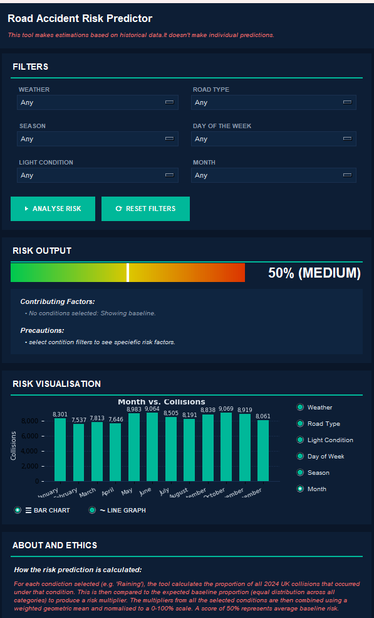
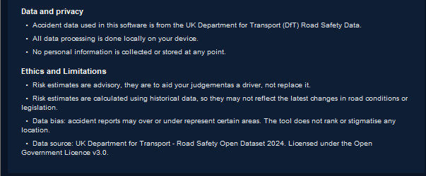

SCREENSHOT OF FILTERS APPLIED
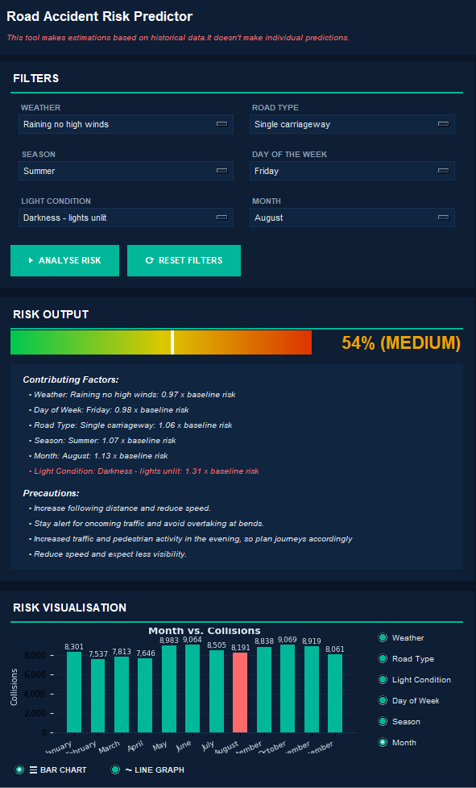
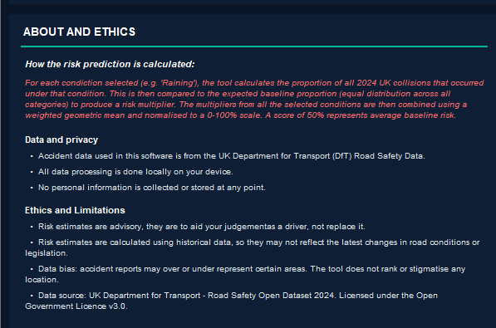

EXAMPLES OF DIFFERENT RISK ANALYSIS BASED ON INPUTS
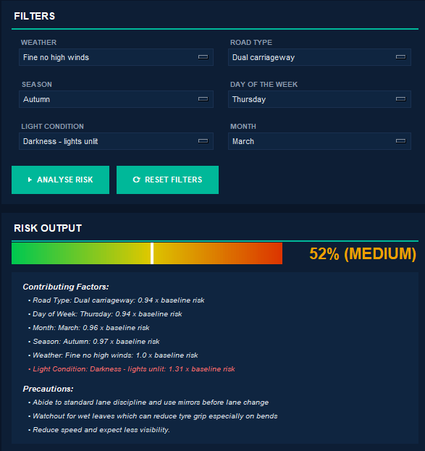
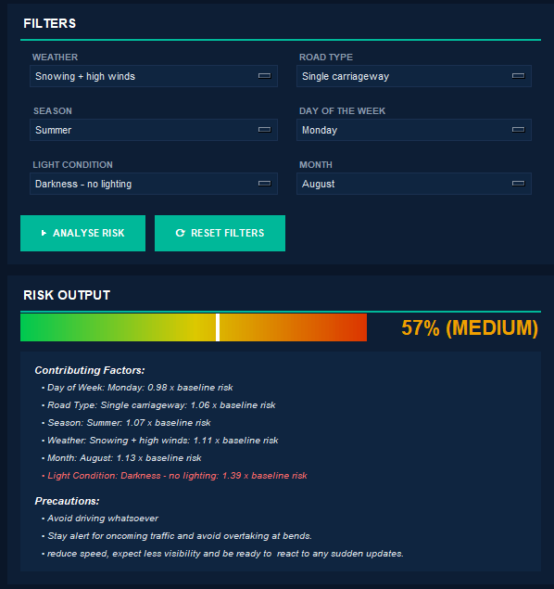
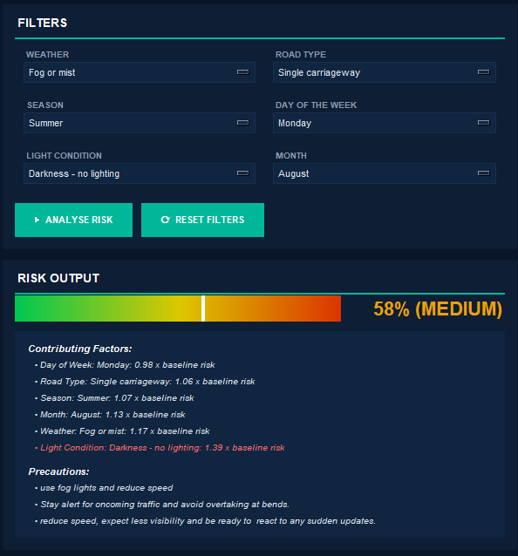

SCREENSHOT CLOSEUP OF ALL SECTIONS
Header
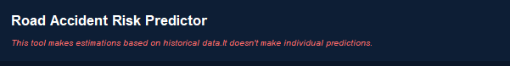
Filters
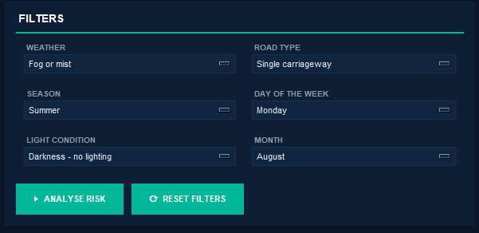
Risk Output
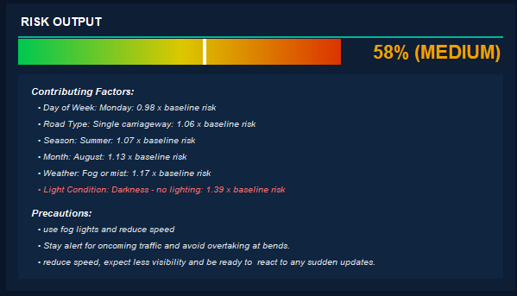
Risk Visualisation (Bar chart)
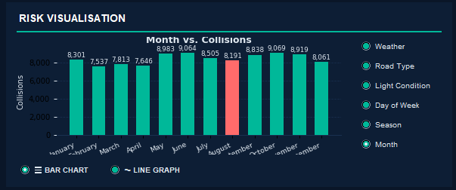
Risk Visualisation (Line Graph)
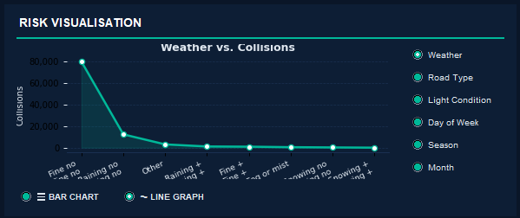
About and Ethics
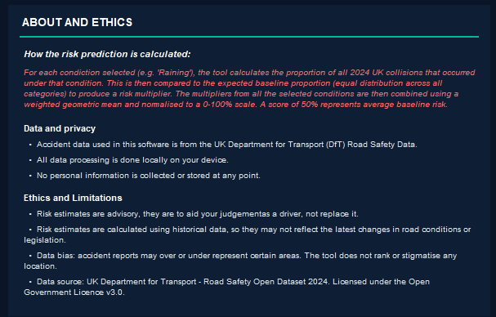

TESTING

TESTS
Number | Description | Expected | Pass
1.1 | Data loading: Loads the official DfT collision CSV using load_dataset(). | It should return a pandas DataFrame with a minimum of 100,000 rows, containing columns: data, weather_conditon, road_type, light_condition and day_of_week | Yes

1.2 | Missing column handling: It attempts loads in a CSV missing a required column | It should return an error message saying which column was missing and then terminate the program using sys.exit(1). To test this, I loaded main.py with a modified version of the csv file that didn’t have the day_of_week column.  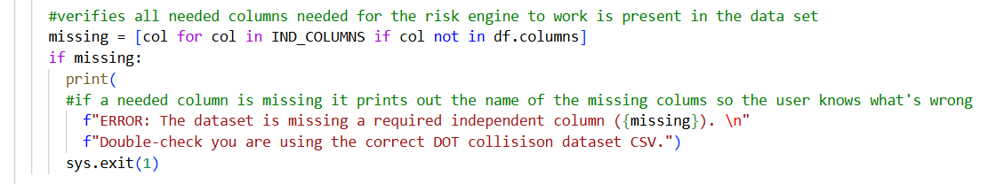  Figure 26 Picture of 1.2 code being tested  Figure 27 Result of 1.2 code testing  The code retuned the expected error message, making this a successful test. | Yes
1.3 | Corrupt file handling: Try to load in a non-DfT collision CSV | It should catch pd.errors.ParseError the error; print out an error message explaining the cause of the crash and then terminate the program. To test this, I changed the document being loaded in the main.py module.  Figure 28 Modified code for testing 1.3  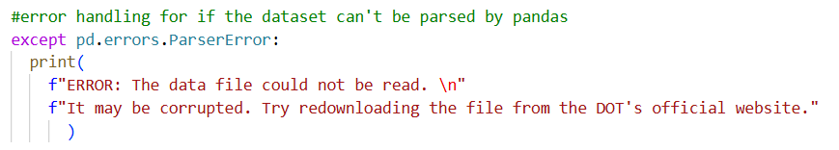  Figure 29 Picture of code being tested 1.3  Figure 30 Result of code testing 1.3  The code returned the expected error message, making this a successful test | Yes
1.4 | Season derivation: Check that the “month” column is correctly mapped to the appropriate “season” using MONTH_TO_SEASON. | For a row with data in December, “season” should be “Winter” and for March “spring”  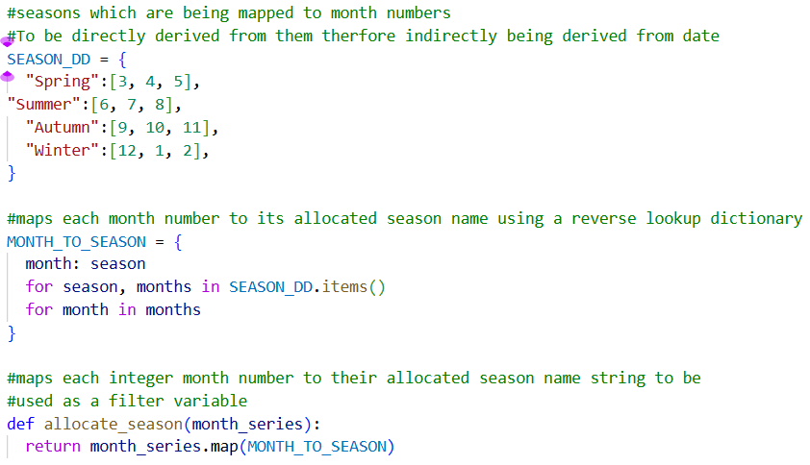 The code successfully maps the seasons to the month code (from the DfT dataset). | Yes
2.1 | Risk calculation with no selected filters: Call calc_risk(df, {}) with all filters set to “Any”. | Returns RiskResult with “percentage=50”, “level=“medium””, “factors = []”, and precautions outputting a prompt for users to select filters.  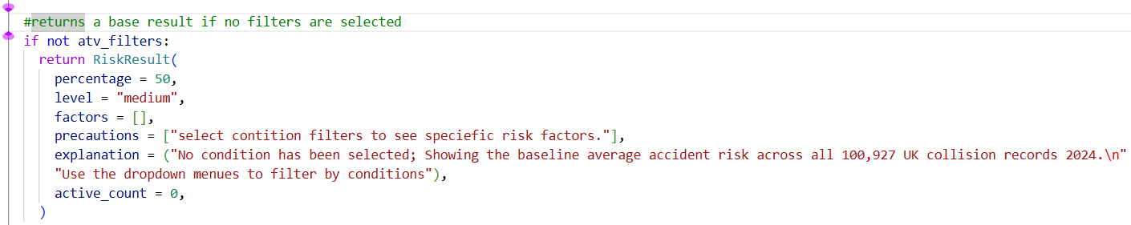  Figure 31 Picture of code being tested 2.1  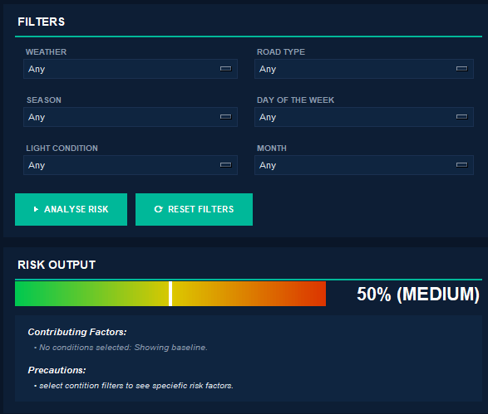  Figure 32 Picture of code being tested  As seen above without any filters the risk output is as 50%, the level is at medium, no factors are being displayed, and precautions is outputting a prompt for users to select filters. Making this a successful test | Yes
2.2 | Risk calculation with multiple selected filters: select “weather_conditions = “Raining no high winds”” and “light_conditions = “Darkness – lights unlit””. | The combined risk percentage should be higher than each individually.  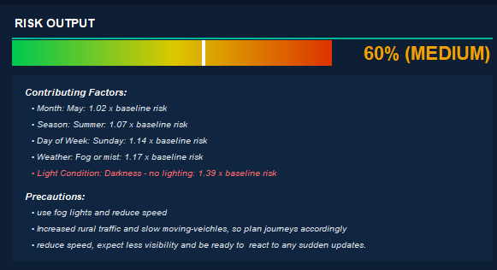  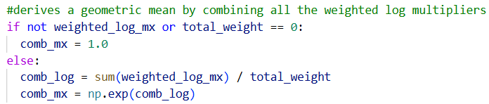  As seen in the test above the results are multiplied together to for a percentage multiplier higher than individual making this test a success. | Yes
2.3 | Risk categorisation (High, Medium, and Low): Calculate a risk that generates a multiplier of greater than 0.5 and one less than 0.5 | Percentage should be “low” when less than 33% and should be “High” when more than 66%  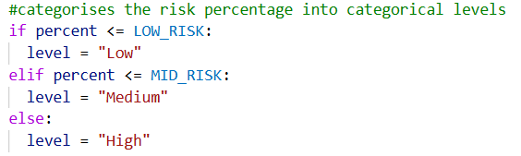  I attempted to evaluate this, but I couldn’t because the highest the risk factor calculator has ever gone is 60 and its lowest forty-five, so it’s not possible to test. I will still consider it a success because it outputs Medium when printing anything else meaning the else function is working so there is a high chance the low and medium risk categorisation are also working. 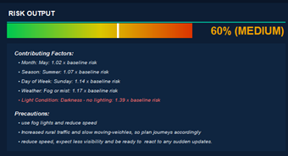 | Yes

3.1 | Precaution advice lookup: Selecting “weather_contitions = “Fog or mist””. | The “precaution” list should output “use fog lights and reduce speed” as its top precaution because weather has a bigger weight than any other filter column.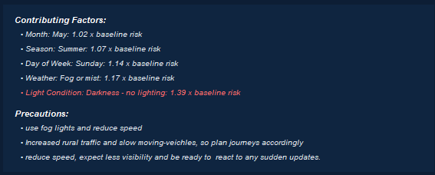  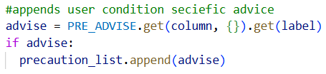  I consider it a successful test because “use fog lights and reduce speed” are at the to of the list. | Yes
3.2 | Contributing factors display: After analysis, “factors” list contains a dictionary with “label”, “multiplier”, “count”. | Should output the label is human-readable text and the multipliers as floats to the two decimal place.  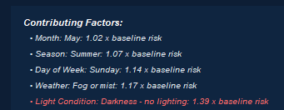  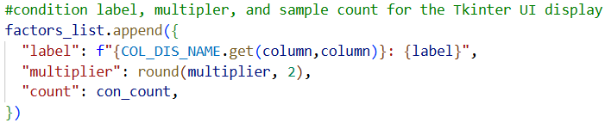  I tested it by running the code above, and it successfully outputted the desired result of a label that is human-readable and a multiplier that is floats to the two decimal places. | Yes
4.1 | Bar chart builder: Call build_chart() with chart_type=”bar” and a breakdown column. | Outputs a bar chart that matches the colour scheme of the other UI elements  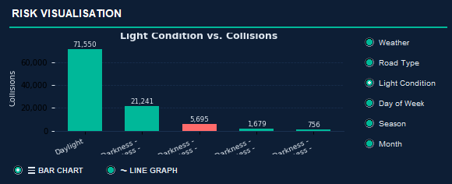  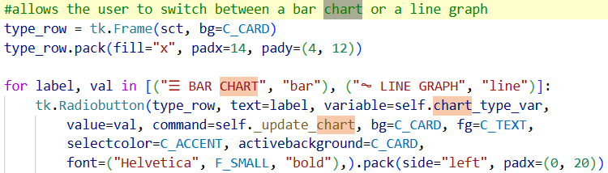  I tested this by running the code above to render the matplotlib chart in Tkinter and then use the radio toggles to see if they swap between line and bar charts and it worked successfully. | Yes
4.2 | Line graph builder: Call build_chart() with chart_type=”line” and a breakdown column. | Outputs a line graph that matches the colour scheme of the other UI elements.  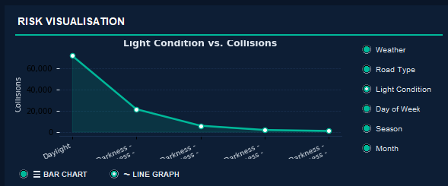    I tested this by running the code above to render the matplotlib chart in Tkinter and then use the radio toggles to see if they swap between line and bar charts and it worked successfully. | Yes
4.3 | Highlight bar: Set the highlight _value to a specific condition code | The bar corresponding to that value is coloured separately from the other in #ff6b6b.  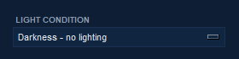  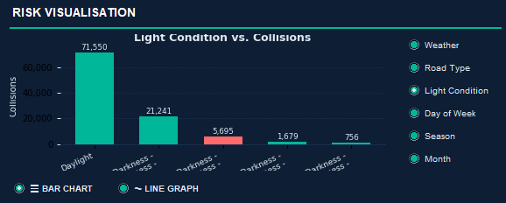  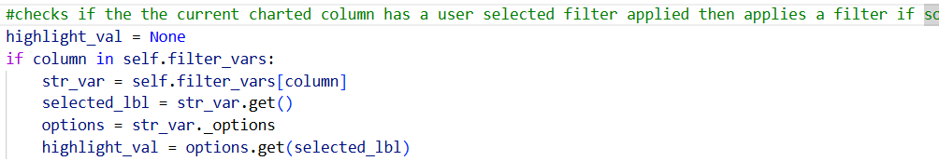  The Darkness – no lighting is selected in the filters so in the charts Darkness-no lighting is a different colour to make it stand out, meaning this test was a success. | Yes
5.1 | UI filter dropdowns: Fills the dropdown menu with all the appropriate filters with a default of “Any”. | get_dd_options() returns dictionary where keys are display labels and values are dataset codes or “None” for any.  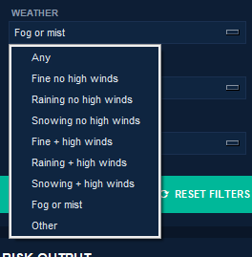  The code works because it returns the labels and displays it in the dropdown menu. So, I’ll consider it a success. | Yes
5.2 | UI filter section and analysis: Selects a value from the drop down (except any) and click on the analyse risk button “ANALYSE RISK” | The risk output updates with the new percentage, level, factors, and precautions. The chart (if showing that column) highlights the selected bar.  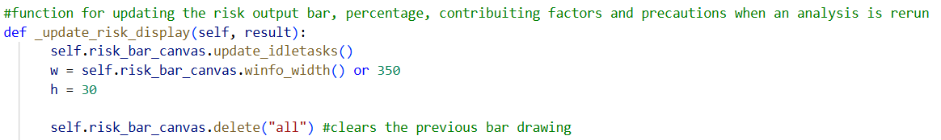  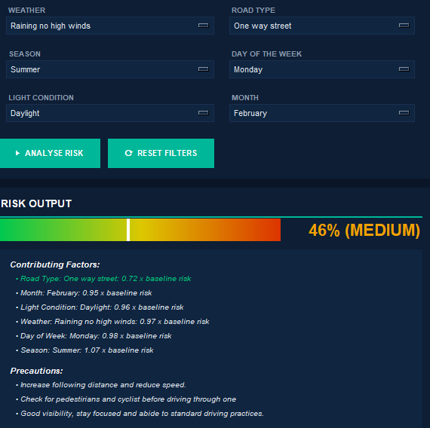  The code section is considered a success because on the click of analyse risk button it outputs, a percentage risk, level, factors, and precautions. | Yes
5.3 | UI reset filters section: Click the reset filter button “RESET FILTERS” | All dropdown menus should return to the default “Any” state and analysis is rerun to show the baseline risk as 50%.  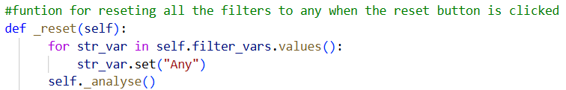    As seen above when the reset filter is clicked all outputs reset to 50%, the level is at medium, no factors will be displayed, and precautions is outputting a prompt for users to select filters. Making this a successful test | Yes
5.4 | UI chart type toggle: Select “LINE GRAPH” radio button. | The chart in the visualisation section should be drawn as a line graph.  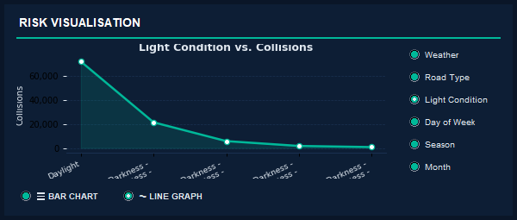  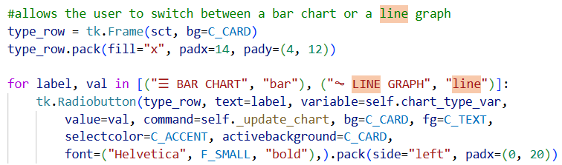  I consider it a success because it swaps from visualising using a bar chart to a line graph using the code run above. | Yes
5.5 | UI chart column selection: Click a different radio button under “RISK VISUALISATION” | The chart should update to show the collision counts broken down by the selected column.  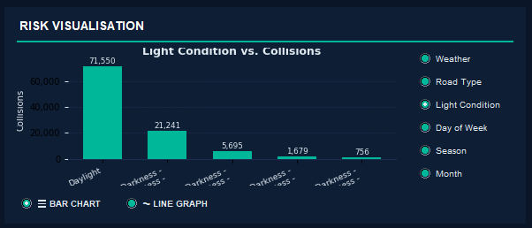  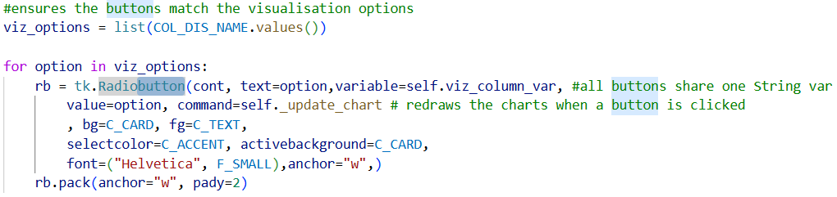  I tested this by running the code above and it was a success because the chars updated whenever I clicked the radio buttons to visualise other columns. | Yes
5.6 | UI risk bar gradient: The risk bar canvas should render a gradient from green to red | “risk_bar_canvas” contain 100 coloured rectangles.  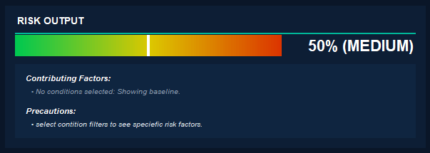  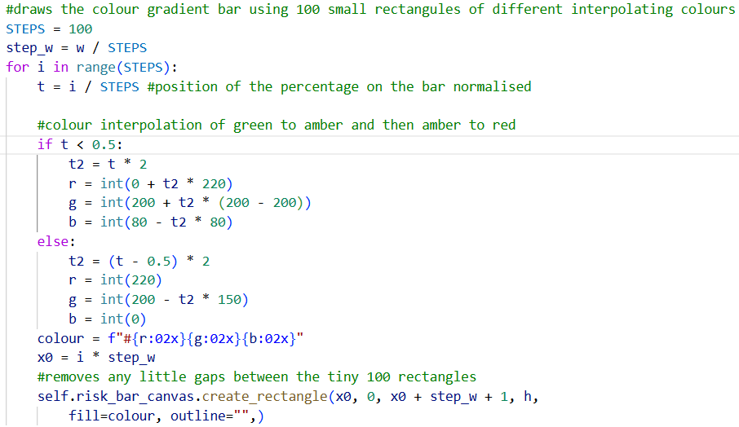  To test this, I will run the code above and it produced a gradient bar as seen in the other screenshot above so I consider this section a success. | Yes

EVALUATION

PROJECT OBJECTIVES
PROJECT OBJECTIVE | DESCRIPTION | COMMENT | PASS OR FAIL
1.1, 1.2 | Import, clean, and process official DfT accident datasets. | Pandas oversaw CSV loading, parsing, and type casting, causing the data pipeline to be dependable.
1.3, 1.4 | Filter by >4 variable efficiently | Dropdowns menus map to five independent variables and DataFrame slicing uses boolean indexing for O(n) efficiency.
2.1, 2.2 | Output a risk estimate calculated using a statistical/ML model. | I used a statistical model (Weighted geometry mean model) to estimate the risk. I did not create a ML model for the sake of user transparency on how the risk estimation data is generated.
2.3 | Display risk as both a percentage and a categorical level | The weighted geometric mean is normalised into a percentage and then a threshold is applied to them outputting both a percentage and a categorical level
2.4, 2.5 | Explain contributing factors and display advisory disclaimer. | Factors are sorted based on their multiplier impact, and we have a disclaimer permanently on the header section of the graph
3.1, 3.2 | Clear visualisations using bar charts and line graphs that update based on user section | I only used Tkinter not seaborn to reduce external library dependencies. Additionally, seaborn was only supposed to be used for the visual aesthetic aspect but using matplotlib I was able to generate a good-looking plot alone.
3.3, 3.4 | Allow pattern interpretations without raw data tables | No raw tables are displayed or used, only bar charts and line graphs.
4.1, 4.2 | Local desktop apps that only requires <6 interactions to generate a risk prediction. | Single page UI allows users to get a risk prediction in less 5 clicks
4.3 | Accessible UI: Typography, contrast, icons and non-tech-savvy language | Consistent high contrast dark theme, consistent Helvetica typography (In my design section I said I was going to use Creato Display but after testing it, I chose to go with Helvetica because it looked cleaner additionally because it’s a default font that means less dependencies), Consistent easy to understand labels through.  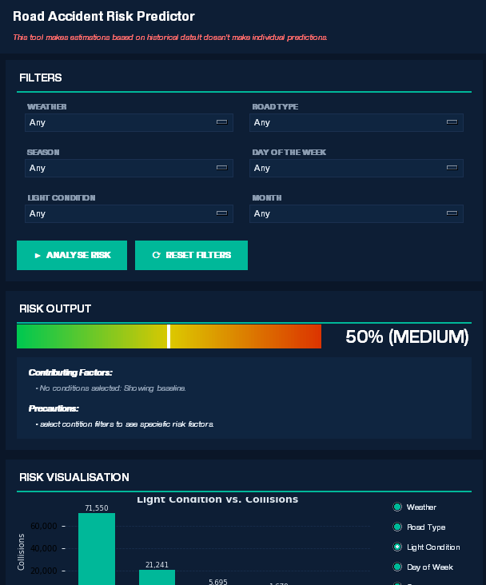  Figure 33 Previous UI using Creato Display
5.1, 5.2 | Display precautionary advice and avoid using scaremongering language. | Contextual precautions are displayed to and the information provided through is factual.
5.3 | Logic transparency to avoid “black box” behaviour. | The about section explains the process of the risk generation in detail.
6.1-6.4 | Legal, ethical, GDPR compliance and local processing | It only works with anonymised open data from DfT. Additionally, they are credited in the about section. All data processing is done locally on devise using and no user data is collected.
7.1-7.5 | Should be free, requiring no account, sharable as a python file with instructions and possible to complete in the NEA timeframe | It can be shared as a free folder containing 4 python modules, a requirements.txt file, a README.md and a 2024 DfT collision data set. It was completed in the NEA project timeline.

CONCLUSION
I belief based on the evaluation of my project objectives that this project was a success.

USER FEEDBACK SURVEY
To test the effectiveness and ease of use of my software, I had 5 of my friends who can drive try it and fill out a survey at the end to give me feedback.

QUESTIONS
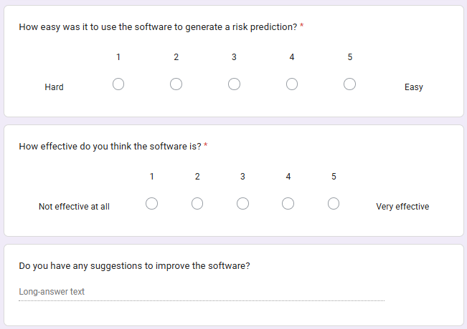

ANSWERS
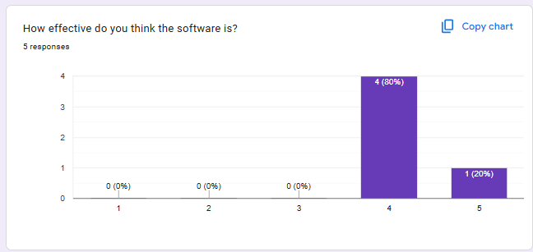
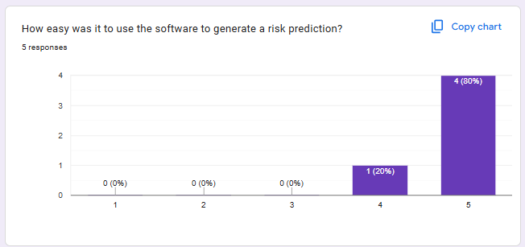
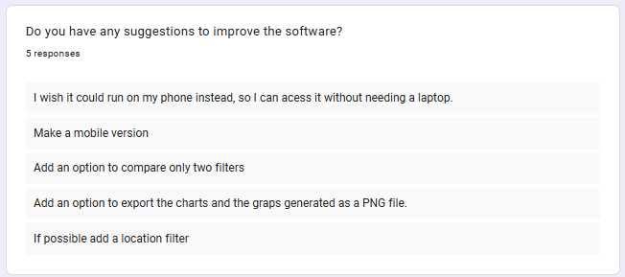
From the response I got from my testers, I conclude that my software is easy to use and effective because all the testers rated them highly with scores of 4-5’s. But based on the suggestions I could make some improvements to the software.

IMPROVMENTS
If I were to revisit this project again these are the improvements I would make, based on user feedback and personal knowledge.
- I would make a web version: Two of my testers suggested I make it run on mobile so, instead of making different versions for different operating systems, I could just make a web version allowing users to run it on both mobile OS and any other device with a browser.
- Add an option to compare two filters: A tester suggested I allow an option to compare two functions, I clarified with him that he meant two filters in the same column. This would be useful to directly comparer conditions like darkness and daytime to understand the risks before making journeys. To achieve this, I could modify the risk output to generate two dropdowns with identical filters.
- Adding an option to export charts: This was a suggestion by a tester to add an option to export the charts and bars as pngs or other formats like pdf. This would be useful so users can use the risk predictions as educational charts. I could implement this by using Matplotlib’s Figure.savefig() method and add a button that triggers filedialoug.asksaveasfilename() to let users choose their desired file format.
- Add a location toggle: This is based off a tester suggestion; this would be useful as some areas have higher accident risk compared to others due to various socio-economic reasons and physical reasons. To implement this, I will just add a new filter menu linked to the location column of the data set and modify the data loader to accommodate locations.

Bibliography
- Statista. (2022). UK households: ownership of mobile telephones 1996-2022| Statista. [online] Available at: https://www.statista.com/statistics/289167/mobile-phone-penetration-in-the-uk/?srsltid=AfmBOooDfaGSvmafyC5OClKIWmZm_08bPmuuuuDNxhvdZmofCtC8LbAf.
- Harper, S.B. and Weber, E. (2022). Fiduciary Responsibility: Facilitating Public Trust in Automated Decision Making. Journal of social computing, 3(4), pp.345–362. doi: https://doi.org/10.23919/jsc.2022.0017

EXTRAS
- Road safety data download link: https://data.dft.gov.uk/road-accidents-safety-data/dft-road-casualty-statistics-collision-2024.csv

